Dale John Madere
1938 – December 18, 2020
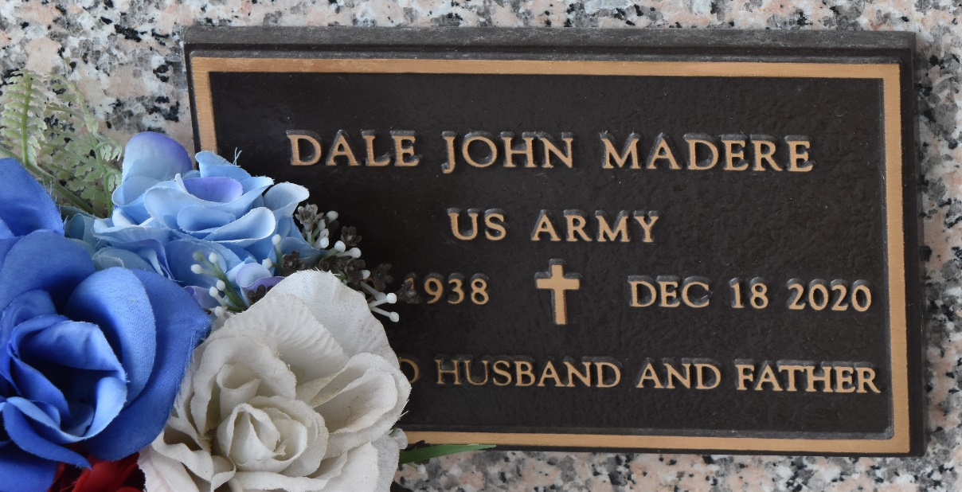

Dale John Madere passed away on Friday, December 18, 2020 at the age of 82. He was a resident of LaPlace, Louisiana. He was a member of the Knights of Columbus and often cooked for various events.
He is survived by his wife of 60 years JoAnn Madere and children Paul Madere, Joseph Madere and the late Ida Barraco, along with six grandchildren and six great-grandchildren.
L'Observateur, LaPlace, Louisiana
Monday, December 21, 2020

