Donna Jo (Ashley) Madere
June 27, 1955 – March 30, 2018
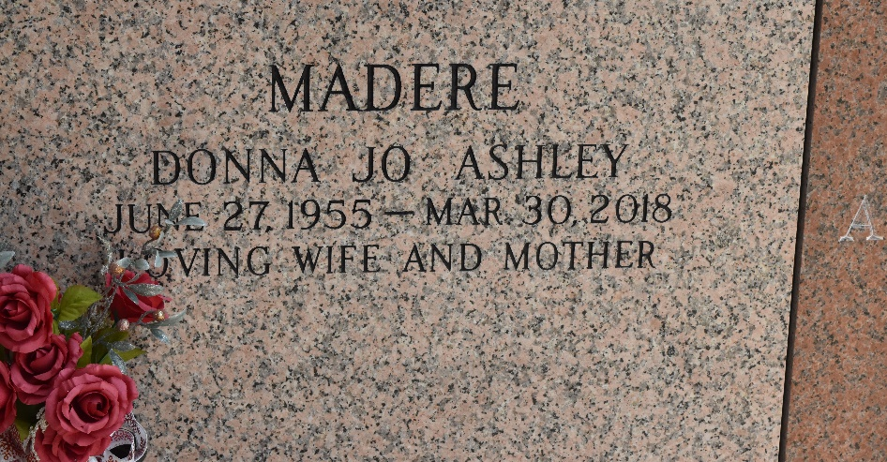
Donna Jo Ashley Madere passed away at her residence surrounded by family members on Friday, March 30, 2018 at the age of 62. She was born in Florence, AL to Ralph and Betty Jo Furgerson Ashley. She was a long time resident of LaPlace. Donna graduated from Leon Godchaux High School in 1973, received her Bachelor’s Degree from Southwestern Louisiana University and her Associate’s Degree in Nursing from Nicholls State University. She retired from the St. John the Baptist School System as a nurse and also worked as a surgical nurse for River Parishes Hospital.
She is the beloved wife of 37 ½ years to Kevin Madere, loving mother of Daniel Madere, and sister of Sandra Ashley Kuykendall and Ramona Ashley Gregory. She was loved by numerous nieces, nephews and other family members. Donna enjoyed gardening, tennis, boating, attending ball games with her husband and fishing with her son.
The family would like to give a special thanks to the doctors and nurses at Mary Bird Perkins Cancer Center and M. D. Anderson Cancer Center. The family would like to give a very special thanks to Dolores Cambre with Eagen Hospice.
Relatives and friends are invited to attend the Funeral Mass at St. Joan of Arc Catholic Church, 529 W 5th Street, LaPlace, LA on Wednesday, April 4, 2018 at 12:00 p.m. Visitation at the church from 10:00 a.m. to 12:00 p.m. Interment in St. John Memorial Gardens Cemetery.

Millet-Guidry Funeral Home, LaPlace, Louisiana
April 1, 2018

