Lawrence J. Madere Jr.

April 12, 1928 – May 9, 2005
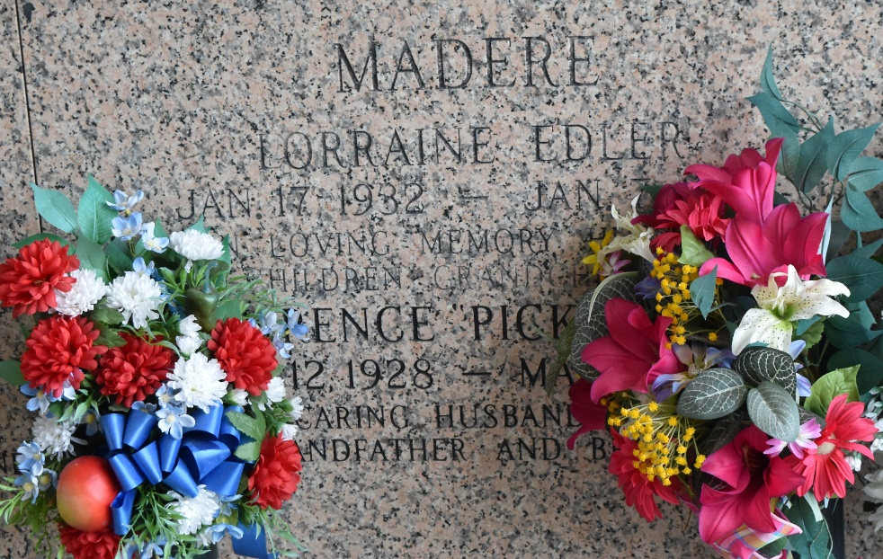

Lawrence J (Pickle) Madere, Jr, died at East Jefferson General Hospital on Monday, May 9, 2005 at 7:22 AM. Beloved husband of the late Lorraine Edler Madere. Father and father-in-law of Bryan and Kim, Brad and Karren, Blaine and Zina (Sam), Lawrence III (L.J.) and Karen, Drew and Paula and Melony Madere. Grandfather of Harmonie Marks, Blaine (B.J.) Madere, Jr., Brandi Madere and Sherry Leboeuf, Amanda and Danielle Cintron, Casey and Christopher Madere, Mason, Chloe and Hope Madere and Shane and Dusty Madere. Son of the late Lawrence, Sr, and Denise Vicknair Madere. Brother and brother-in-law of Harry and Maureen and Kenneth and Linda Madere.
He was a retired employee of Dupont, an Army Veteran and Parishioner of St Joan of Arc Catholic Church. Age 77. A native and resident of Laplace, La.
Relatives and friends of the family are invited to attend services. Visitation at Millet-Guidry Funeral Home, 2806 West Airline Hwy, Laplace, LA on Wednesday, May 11, 2005 from 5PM to 10PM and on Thursday from 8AM to 10:15 AM. Followed by religious services at St Joan of Arc Catholic Church, Laplace, LA, at 10:30 AM. Burial in St John Memorial Gardens, Laplace.

The Times-Picayune, New Orleans, Louisiana
May 10, 2005

