Pearl (Montz) Madere

June 6, 1922 - November 15, 2014
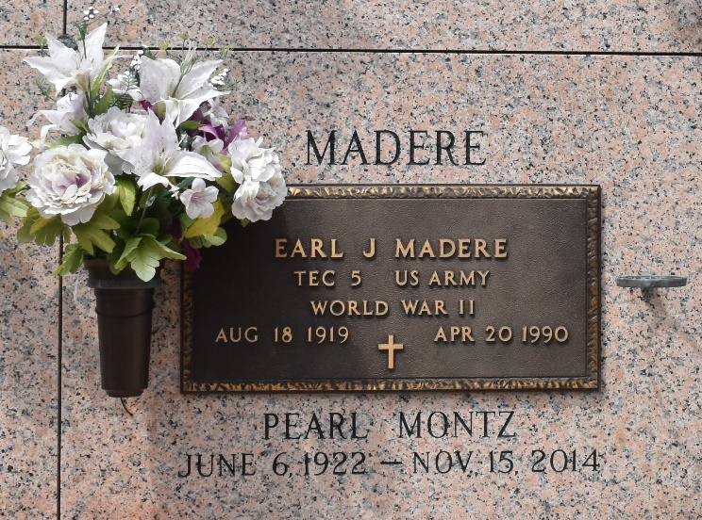
Pearl Montz Madere passed away peacefully on Saturday, November 15, 2014 at the age of 92. She was a native of Lions, LA, was a resident of LaPlace, LA for over 50 years, and for the past seven years she was a resident of First Care Nursing Home in Fosston, MN.
Beloved wife of the late Earl J. Madere. Loving mother of Jo Ann Levet (Larry), Yvette Baron (J.B.) and Tanya Roccaforte (Barry). Daughter of the late Virginia Cambre and Maurice Montz. Sister of the late Lillian Griffin, Yolande Landry and Daniel, Elmore, Quincy, Floyd and Vivian Montz. Grandmother of Shelly Ernst (Lester), Kelly Curtis, Aimee Bourgeois (Pab), Angelle Farrell (Bart), Mike Roccaforte (Kristin), Jeff Roccaforte (Amanda) and the late Perry Levet. Great-Grandmother of Gabrielle, Jeanne and Maddy Levet; Camryn and Chloe Ernst; Leslie, Courtney and Christina Curtis; Baylie, Paisley and Reese Bourgeois; Ella Pearl, Amelia and Olivia Farrell and Brody, Brinley and Janie Roccaforte. She is also survived by three sisters-in-law and numerous nieces and nephews. Ms. Pearl was loved by all and will be greatly missed.
The family would like to extend their heartfelt appreciation to the staff of First Care Nursing Home for their love and dedication to Ms. Pearl.
Relatives and friends are invited to attend the Funeral Mass at St. Joan of Arc Catholic Church, 529 W. 5th St., LaPlace on Monday, November 24, 2014 at 12:00 Noon. Visitation will begin in church at 9:00 a.m. Interment in St. John Memorial Gardens Cemetery.

Millet-Guidry Funeral Home, LaPlace, Louisiana

