Robert J. Madere
August 23, 1942 – February 4, 2006

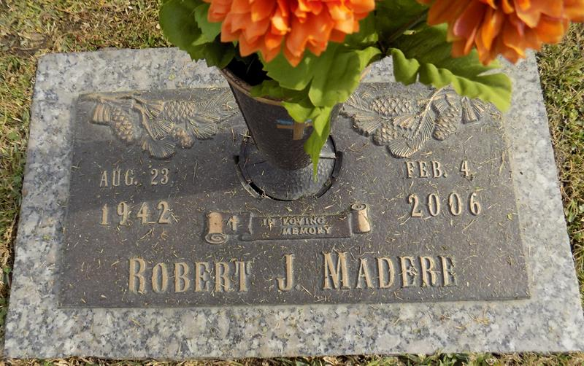

LAPLACE - Robert J. "Bobby" Madere, 63, a native and resident of LaPlace, died Feb. 4. He was the son of the late Clancy and Margaret Madere. He is survived by his brother Clancy D. Madere. He was preceded in death by his siblings Douglas, James, Michael and Katherine Madere and Deborah Acosta.

Services were held Feb. 7 at St. John Memorial Gardens, LaPlace.
L'Observateur (La Place, LA)
Thursday, February 9, 2006

