Robert W. Madere
1932 – March 28, 2004
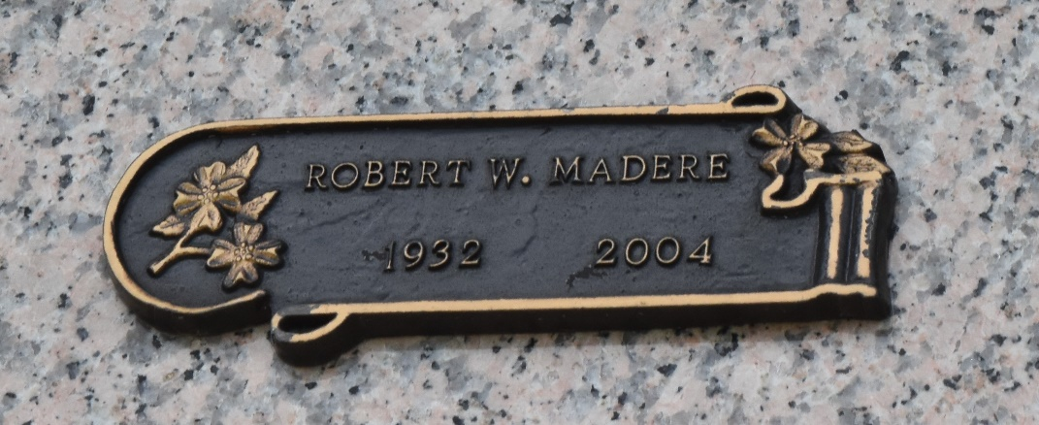

Robert W. Madere on Sunday, March 28, 2004 at 11:00 P.M. Beloved husband of Carolyn Guidry Madere. Father of Troy Madere and Amanda Madere. Grandfather of Jamie Lynn LeBlanc, Elisa and Troy Madere, Jr. Son of the late Robert P. and Simone Madere. Brother of Judy Evans. Age 71. A native and resident of Laplace, LA.

Relatives and friends of the family, also members of the New Orleans Track Club are invited to attend services. Visitation at St. Joan of Arc Catholic Church, Laplace on Friday, April 2, 2004 from 10:00 A.M. until 11:00 A.M. followed by Memorial Services in the church at 11:00 A.M. Arrangements by MILLET-GUIDRY FUNERAL HOME, LAPLACE, LA.

The Times-Picayune, New Orleans, Louisiana
March 30, 2004

