David R. Malain
May 22, 1959 – November 12, 2011

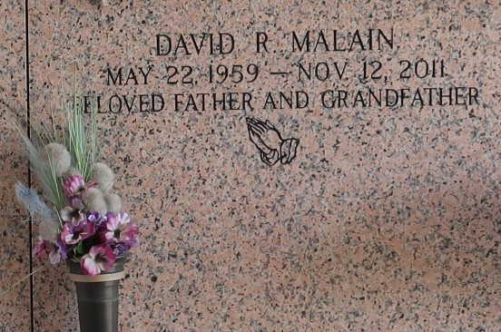

David R. Malain passed away on Saturday, November 12, 2011. Beloved Father of Brittney Malain Brignac and Cody Malain. Grandfather of Jacob, Luke and Elijah Brignac. Son of the Eva Summers Malain and the late Louis Malain Sr. Brother of Louis Jr. (Joette), Alan (Debbie), Robert and Timothy Malain (the late Robin). Age 52. A native of New Orleans, LA and a resident of LaPlace, LA.

Relatives and friends are invited to attend services. Visitation at Millet-Guidry Funeral Home, 2806 W. Airline Hwy., LaPlace, LA on Tuesday, November 15, 2011 from 10:00 am to 12:00 noon, followed by Religious Services in the Funeral Home Chapel at 12:00 noon. Burial in St. John Memorial Gardens Cemetery, LaPlace, LA.

The family would like to give special thanks to St. Catherine's Hospice for their care and support.

The Times-Picayune, New Orleans, Louisiana
Nov. 12 to Nov. 13, 2011

