Eva Kathleen (Summers) Malain
May 22, 1959 – November 12, 2011

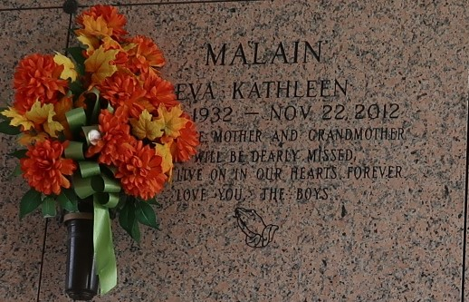

Eva Kathleen Summers Malain passed away on Thursday, November 22, 2012. Beloved wife of the late Louis Malain, Sr. Mother of Louis, Jr. (Joette), Alan (Debbie), Robert and Timothy Malain (the late Robin) and the late David Malain. Grandmother of 12 grandchildren and 11 great-grandchildren. Daughter of the late Floyd and Cecil Summers. Sister of Mary Nell Moak, Marie Wheeler and the late Floyd, Jr. and Billy Summers. Sister-in-law of Nelma Summers. Also survived by nieces and nephews. Age 80. A native of Baskin, LA and resident of LaPlace for the last 47 years.
The family would like to give special thanks to Eagan Home Health and Eagan Hospice for their care and support in our time of need.
Relatives and friends are invited to attend services. Visitation at Millet-Guidry Funeral Home, 2806 W. Airline Hwy, LaPlace, LA on Monday November 26, 2012 from 8:00 a.m. to 10:00 a.m., followed by Religious Services in the Funeral Home Chapel at 10:00 a.m. Burial in St. John Memorial Gardens, LaPlace, LA.

The Advocate, Baton Rouge, Louisiana
Nov. 23 to Nov. 26, 2012

