Eula Mae Stoute Marks
December 3, 1938 - September 23, 2023

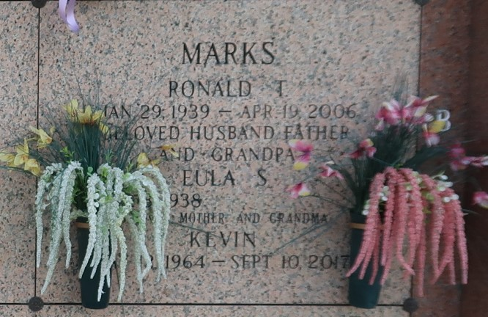

Eula Mae Stoute Marks passed away on Saturday, September 23, 2023. She was a native of Leonville, LA and a resident of Hammond, LA.
Beloved wife of the late Ronald T. Marks. Loving mother of Phyllis Laurent (Stephen), Josh Toby Marks (Kila), Nikki Chantel Fazzio (Tony) and the late Bryan Kent Marks, Thomas Kevin Marks and Danielle Rebstock (Darren). Daughter of the late Evelyna Guidry Stoute and Gerard Stoute. Sister of Bertha Darbonne, Ruby Latiolas (Raymond), Lucille Dupre, and the late Joseph Stoute, Edna Robin, Gilda Robin, Liza Johnson, Evelyn Bazar, Curly Stoute and Thomas Stoute. Also survived by 14 grandchildren 28 great-grandchildren and many nieces and nephews.
Relatives and friends are invited to attend the Memorial Visitation and Mass at St. Joan of Arc Catholic Church, 529 W. 5th Street, LaPlace on Saturday, September 30, 2023. Visitation at church from 9:30 a.m. until time of Mass at 11:30 a.m. Inurnment will follow in St. John Memorial Gardens Cemetery.

Millet-Guidry Funeral Home, LaPlace, Louisiana
September 26, 2023

