Ronald T. Marks
January 29, 1939 – April 19, 2006

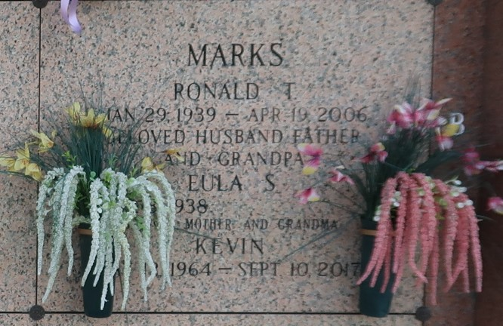

Ronald T. Marks on Wednesday, April 19, 2006 at 4:00 p.m. Beloved husband of Eula Marks. Father of Phyllis Laurent, Toby Marks, Kevin Marks, Nikki Fazzio, Danielle Rebstock and the late Kent Marks. Also survived by 14 grandchildren and 3 great-grandchildren. Age 67. A native of Port Barre, LA and a resident of Laplace, LA for the past 35 years.
Relatives and friends of the family are invited to attend services. Visitation at Millet Guidry Funeral Home, 2806 West Airline Hwy, Laplace, on Friday, April 21, 2006 from 5:00 p.m. to 9:00 p.m. and on Saturday from 8:00 a.m. to 9:45 a.m. followed by religious services at St. Joan of Arc Catholic Church, LaPlace at 10:00 a.m. Burial in St. John Memorial Gardens Cemetery, LaPlace.
The Times-Picayune, New Orleans, Louisiana
Apr. 21, 2006

