Thomas Kevin Marks
May 12, 1964 – September 10, 2017

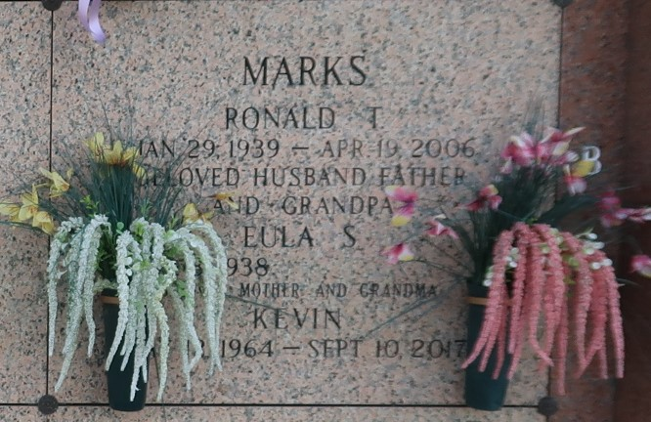

Thomas "Kevin/Jotco" Marks, 53, of Reserve, LA., passed away peacefully in his home surrounded by family and friends on September 10, 2017 at 4:45p.m.
He was born May 12, 1964, the son on Eula Stoute Marks and the late Ronald T. Marks.
Kevin is survived by his significant other/soulmate of 18 years Cynthia M. Bowman, his only son Tyler T. Marks, grandson Josiah T. Marks, and chosen daughter Sarah Bowman. He is also survived by his mother Eula Stoute Marks; Sisters, Phyllis Laurent(Stephen), Chantel "Nikki" Fazzio(Tony); Brother, Josh "Toby" Marks(Kila); Brother in law, Daren Rebstock(late Danielle) and many aunts, uncles, nieces, nephews and friends.
Kevin was preceded in death by his father Ronald T. Marks; brother, Brian "Kent" Marks; and sister, Danielle M. Rebstock (Daren).
Kevin was our Rebel with a heart of gold. He was loved by all who knew him and no one was a stranger!!
Family and friends are invited to attend the Funeral Services as follows: Wednesday September 13th, 8am - 10am followed by Mass at St. Peter's Catholic Church, 1550 La-44 Reserve, La. 70084

Unknown source

