Graciela Marroquin
July 2?, 1926 – September 11, 2006

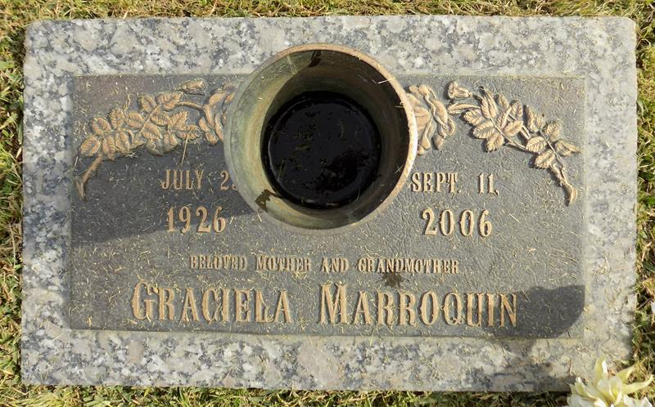

Graciela Marroquin on Monday, September 11, 2006 entered into eternal rest. Survived by: 1 son, Oscar Marroquin; 1 grandson, Bryam Marroquin; 3 nephews: Victor, Hugo and Gilberto Marroquin; and a host of relatives and friends.
Funeral Service on Saturday, September 16, 2006 at 11:00 a.m. at Louisiana Undertaking Co., 1449 N. Claiborne Ave. Visitation on Friday, September 15, 2006 from 3:00 until 6:00 p.m. at Louisiana Undertaking Co. Officiated by Rev. Abel Ruano. Final resting place, St. Mark Cemetery (sic).
Relatives and friends of the family are invited to attend the services. Professional services entrusted to: GASKIN-SOUTHALL-GORDON & GORDON MORTUARY, 1225 N. Rampart St., N.O., LA, Information: (504) 566-9000.
Times-Picayune, The (New Orleans, LA)
Friday, September 15, 2006

