Anna Lee (Vedros) Martin
March 24, 1924 – September 12, 2005

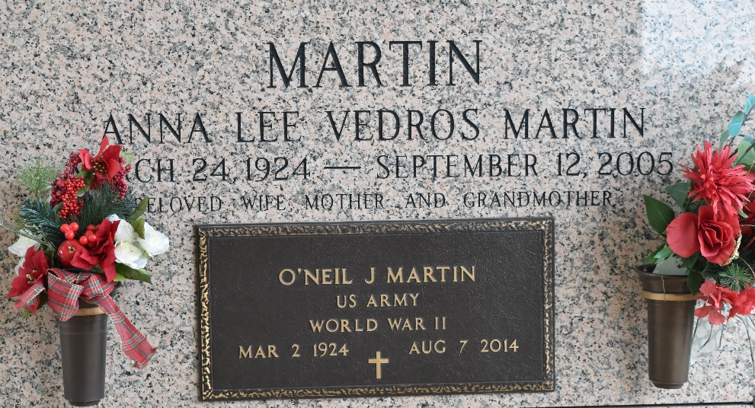

A native of Lutcher and a resident of LaPlace for the past 50 years, she died Monday, September 12, 2005, at 9:13 PM. She was 81, a retired proof reader for the L'Observateur newspaper and a retired secretary for H. Martin Oil Co.
She was the beloved wife of O'Neil Martin, mother of Charlotte Petersen and Debbie Martin, grandmother of Beth Surmik Fountain, Mark Andrew Surmik and the late Robbie Englade, great-grandmother of Amber Englade and Ashley Chenier, sister of Eula V. Lucia, Jamsel "Jimmy" Vedros and the late Doris V. Bernard, Ione V. Bourgeois and Percy Vedros, daughter of the late Ellis C. and Laura Comeaux Vedros, and godmother of Ellis Lucia, Jackie Bourgeois, Carolyn V. Hyeart and Dennis Arceneaux. She also is survived by a host of nieces, nephews, other relatives and friends.
Relatives and friends of the family were invited to attend visitation at Millet-Guldry Funeral Home, 2806 W. Airline Highway, LaPlace, on Friday, September 16 from 5:00 PM to 9:00 PM and on Saturday, September 17 from 8:30 AM to 9:45 AM, and was followed by religious service at St. Joan of Arc Catholic Church, LaPlace, at 10:00 AM. Burial in St. John Memorial Gardens, LaPlace.

The Times-Picayune, New Orleans, Louisiana
Sep. 30, 2005

