Eloise Theresa Martin
April 29, 1959 – November 21, 2019
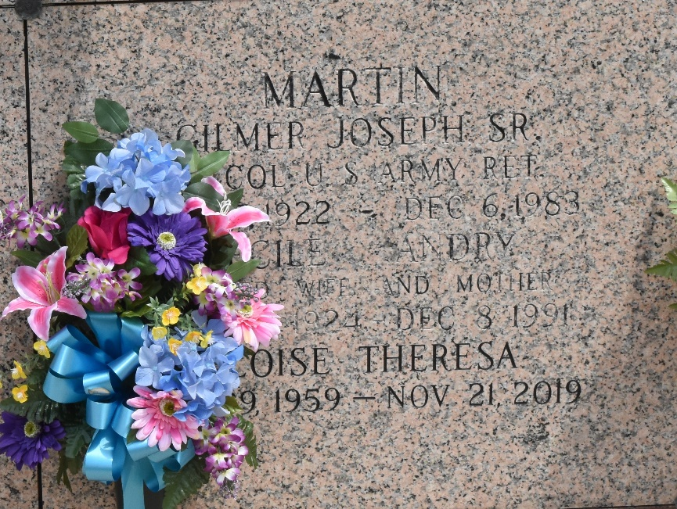
Eloise Theresa “Tootie” Martin died on Thursday, November 21, 2019 at her home. She was 60 years old and had never married and had no children.
She was preceded in death by her parents, Gilmer J. Martin, Sr. and Cecile Andry Martin; two brothers, Clark “Chuck” V. Martin and Kim "Soupy” Charles Martin.
She was a long time member of St. Joan of Arc Church and participated in the Choir. As a teen she taught children to dance and performed in many theatre shows with St. John Community Theatre. She loved to dance and sing which brought joy to many people.
She is survived by a brother, Rev. Gilmer J. Martin and two sisters, Myrle Triche of Orange Park, FL and Lynne Bennett of LaPlace. She is also survived by many nieces and nephews.
Relatives and friends are invited to attend the Funeral Service at St. Joan of Arc Catholic Church, 529 W. 5th St., LaPlace on Wednesday, November 27, 2019 which include the visitation from 9:30 a.m. to 11:30 a.m. and Burial Mass to follow immediately after. Interment will be at St. John Memorial Gardens Cemetery, 2205 W. Airline Hwy in LaPlace.

Millet-Guidry Funeral Home, LaPlace, Louisiana

