James Cluis Martin

November 18, 1941 – September 1, 2000

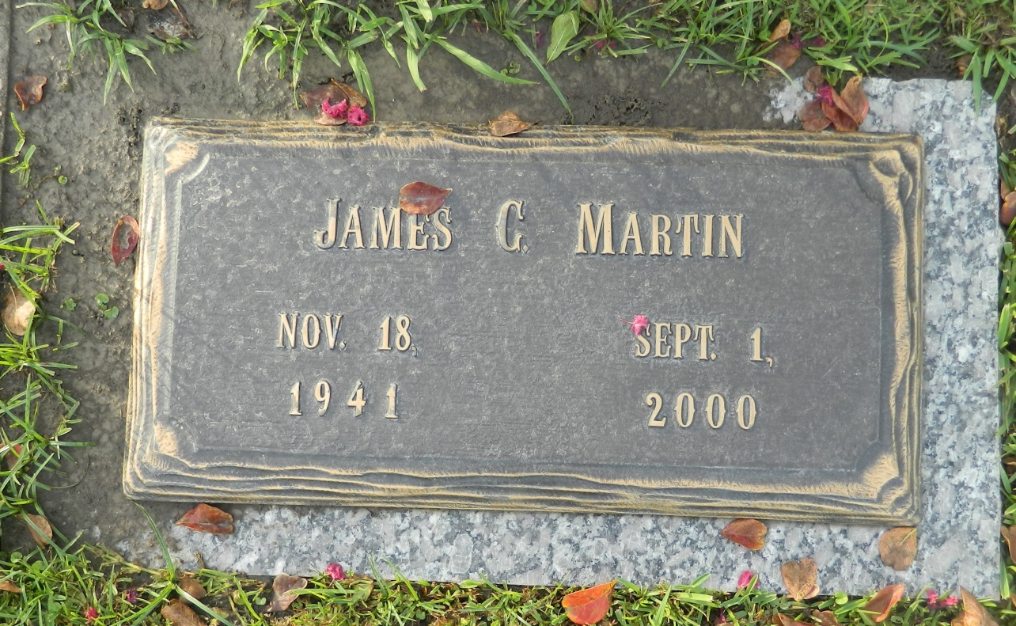

James Cluis Martin, an assistant superintendent for Archer Daniels Midland Company, died Friday of cancer at his home. He was 58. Mr. Martin was born in Heidelburg, Miss., and lived in LaPlace before moving to Ponchatoula seven years ago. Mr. Martin served as a missionary in Africa. He is a member of Jehovah's Witnesses, where he served as an elder in the Ponchatoula congregation.

Survivors include his wife, Elaine Martin; two sons, Marcel and Maurice Martin; a stepson, Jonathan Hebert; a stepdaughter, Tessa Hebert; five brothers; five sisters; and a grandchild. Services will be held at a later date and announced from the local congregation of Jehovah's Witnesses. Harry McKneely and Sons Funeral Home in Ponchatoula is in charge of arrangements.

Times-Picayune, The (New Orleans, LA) - Sunday, September 3, 2000

Contributed by Jane Edson