Jean I. (Edler) Martin
August 1, 1937 – May 16, 2017

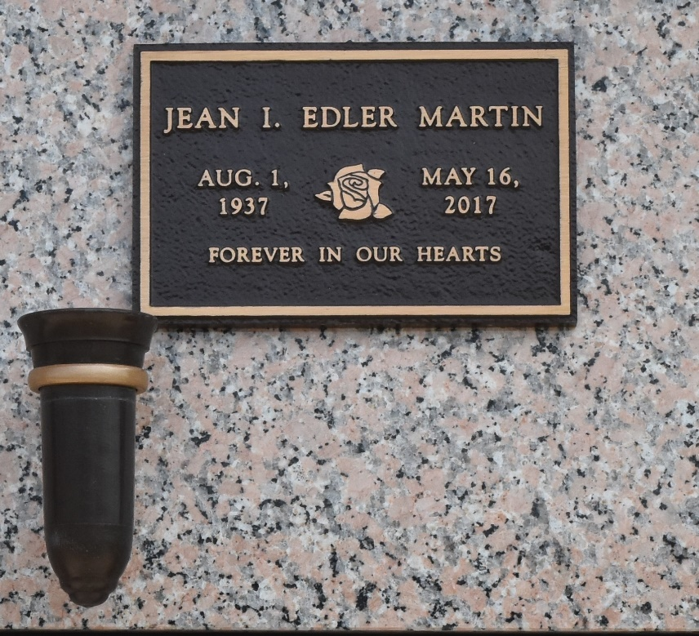

Jean Edler Martin passed away from this world on May 16, 2017, at the Belle Maison Nursing Home in Hammond surrounded by her loved ones.
Born to Lelia Lemoine and Louis Edler in Crevasse on Aug. 1, 1937, in her younger years she enjoyed bowling and fishing. She loved to cook, eat good food, chat with family and friends and she enjoyed nature. She called everyone “Sha.” She always said how proud she was of her grandchildren and loved visits from her great grandchildren. She leaves behind her children Romona “Mona” Middlebrook (Wayne), Jody Becnel, Craig and Eric Martin; grandchildren Hayden and Wesley Middlebrook, Donavon, Dustin and Layla Becnel, and Cory Martin; great grandchildren Chandler, Rachel, Nicholas, Cassidy and Kieley Middlebrook, Caden Millet, Jake, Gracie, Beau, Collyn, Cale and Cohen Becnel.
She was preceded in death by her husband, Alcide Joseph (A.J. Martin) Jr.; her parents; stepfather Lawrence (Butch) Edler; and siblings Anna Gendron, Lorriane Madere and Roy Edler.
Special thank you to the Memory Care Unit at Belle Maison Nursing Home. Also, thank you for the compassionate care from New Century Hospice.
Visitation is from 3 to 5 pm Friday, May 19 with a service at 5 p.m. at Baloney Funeral Home, 1905 West Airline Highway in LaPlace. A private burial will be held at a later date. In lieu of flowers, donations should be made to the Alzheimer’s Foundation at 866-232-8484.

L'Observateur, LaPlace, Louisiana
Thursday, May 18, 2017

