Adam Mason
May 10, 1939 – January 19, 2015

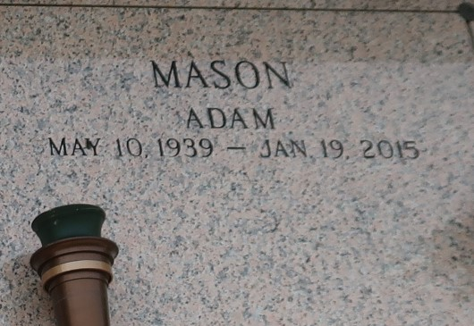

Adam "Bruh" Mason, age 75 years, departed this earthly life on Monday January 19, 2015. A native and resident of Reserve, La. Beloved Husband of Lutha Mae Mason for 46 years. Loving father of Shawanda, Kentrell, Treva Mason and Travis Shallow. Grandfather of Maisha Tyiesha, Kailiah, Kentrell, Kenadja, Kendez Mason, Jucoy Becnel, Kalip Edward and Michael Thomas. Great-grandfather of Harlei Mason. Brother of Henry Mason (Yvonne), Alexander Mason (Veronica), Michael Mason (Waddie), Audrey Grover (Williams), Raymond Mason (Geraldine), Royal, Alvin and Joeann Mason and the late Peter, Roland, Louis and Clarence Mason. Brother-in-law to Shirley, Louise, Hattie and Laddie Mason. Also survived by a host of nieces, nephews, other relatives and friends. A devoted friend of Kenneth Wayne Jenkins.
Pastors, Officers and Members of the Beechgrove Baptist Church of Reserve, La., From My Heart To Yours FWC and all neighboring churches are invited to attend the home-going celebration on Saturday, January 24, 2015 at 10:00am at the Beechgrove Baptist Church, 117 Beechgrove Dr., Reserve, La. where the host pastor is Rev. Wesley Anderson. Pastor Carla C. Ceaser officiating. Visitation at the Beechgrove Baptist Church from 8:00am until service time. Interment in St. John Memorial Garden of Laplace, La. Bardell's Mortuary of Mt. Airy. La in charge. Information: 985-535-6837.

The Times-Picayune, New Orleans, Louisiana
Jan. 22 to Jan. 23, 2015

