Kentrell Michael Mason Sr.
May 18, 1977 – January 14, 2019
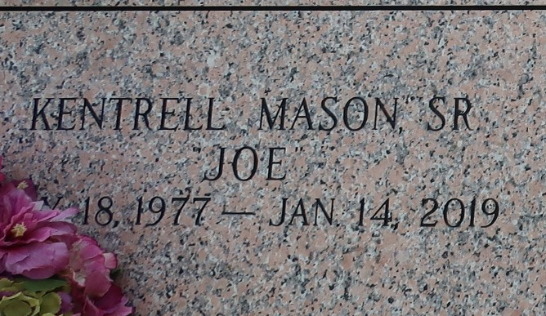

Kentrell "Joe" Michael Mason Sr. at the age of 41 years departed this earthly life and entered into eternal rest on January 14, 2019 at his residence in Reserve, LA. He was born on May 18, 1977 to the late Adam "Bruh" Mason and Lutha Mae Mason. Loving father of Ka'liah, Kentrell Jr., Kenadja, Kendez Mason and Kalip Edwards. Brother of Shawanda Mason, Treva (Justin) Becnel, and Travis Sharlow. Also survived by 2 nieces, Tyeisha and Maisha Mason, 1 nephew Jucoy Becnel, 1 great niece Harlei Mason, aunts, uncles, other relatives, and friends. Kentrell was preceded in death by his father Adam "Bruh" Mason, grandparents Peter Sr. and Mary Mason, Willis and Semonia Young. A native and resident of Cornland.
Pastors, officers, and members of From My Heart to Yours Family Worship Center of LaPlace, LA and all neighboring churches are invited to attend the homegoing celebration on Saturday, January 19, 2019 at 11:00 a.m. at From My Heart to Yours Family Center of 119 West Fifth St. LaPlace, LA. Pastor Carla C. Ceaser officiating. Interment in St. John Memorial Garden of LaPlace, LA. Visitation will be at the above name church from 9:00 a.m. until service time. Bardell's Mortuary of Mt. Airy, LA in charge.

Published in TheNewOrleansAdvocate.com
Jan. 17 to Jan. 19, 2019

