Louis Mason
1932 – January 18, 2003
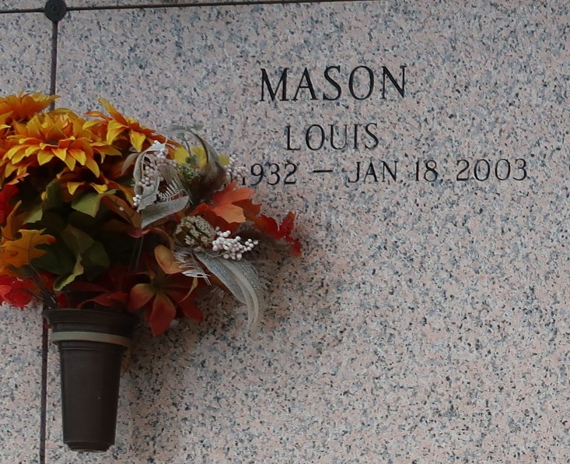

RESERVE - Louis Mason, 70, a native of Reserve and resident of Lutcher, died Jan. 18. He was the husband of Hattie Meredith Mason, father of Karen Banks, Pamela Lennix, Verenise Simoneaux and Kim Parquet, adopted father of Allen, Warren and TaShana Mason and foster-father of Nasha Wilson and Charles and James Jones. He was the brother of Audrey Grover and Jo-Ann, Roland, Henry, Royal, Raymond, Michael, Alvin, Alexander, Peter Jr. and Adam Mason. He is also survived by 10 grandchildren and one great-grandchild. He was a retired forklift operator with Filter-Media.

Services were Jan. 25 at Beechgrove Baptist Church, Reserve, with interment at St. John Memorial Gardens, LaPlace.
L'Observateur, LaPlace, Louisiana
Tuesday, February 4, 2003

