Max C. Mason
June 12, 1928 – October 31, 2009

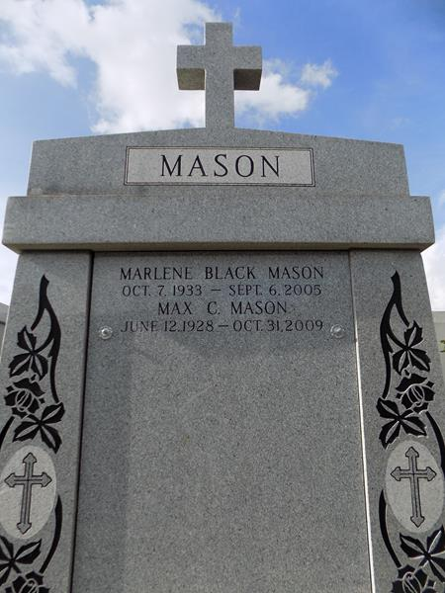

Max Mason passed away on Saturday, Oct. 31, 2009. Beloved husband of the late Marlene Mason. Father of Billy, Greg and Jerry Mason. Grandfather of Joey, Jennifer, James and Emily Mason. Brother of Agnes Beard and Mary Beth McKnight. Age 81. A native of Lillie, La. And a resident of LaPlace.

Relatives and friends also employees of Entergy are invited to attend services. Visitation at Millet-Guidry Funeral Home, 2806 W. Airline Hwy., LaPlace, on Thursday Nov. 5, from 5 p.m. to 8 p.m. and on Friday from 8 a.m. to 10 a.m. Followed by Religious Services in the funeral home chapel at 10 a.m. Burial in St. John Memorial Gardens Cemetery, LaPlace.
L'Observateur (LaPlace, LA)
Tuesday, November 3, 2009

