Jeffrey Paul Massi

October 22, 1963 - December 4, 2022

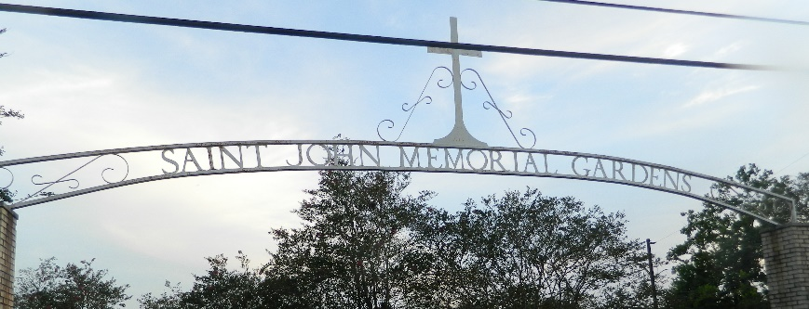

Jeffrey Paul Massi passed away on Sunday, December 4, 2022 at the age of 59. He was born in Lutcher and a resident of LaPlace, Louisiana.
Jeff proudly served in the US Navy for 6 years. He then worked as a Service Engineer at Konecranes Company for over 16 years. He also loved fishing and being outdoors.
Beloved husband of Anita Massi. Son of Dorothy Massi and the late Nathaniel Massi. Brother of David Massi (Sabra) and Jennifer Massi. Uncle of Jennifer Mayer Davis (Bryan) and the late Kristi Massi Willhite (Jeremy).
Relatives and friends are invited to attend the Visitation and Funeral Mass at Millet-Guidry Funeral Home, 2806 W. Airline Hwy., LaPlace on Wednesday, December 7, 2022. Visitation from 9:00 a.m. to 11:00 a.m. followed by a Funeral Mass at 11:00 a.m. Interment in St. John Memorial Gardens Cemetery, LaPlace, LA.

Millet-Guidry Funeral Home, LaPlace, Louisiana

