Kathleen (Varner) Massi
August 1, 1958 – February 5, 2022
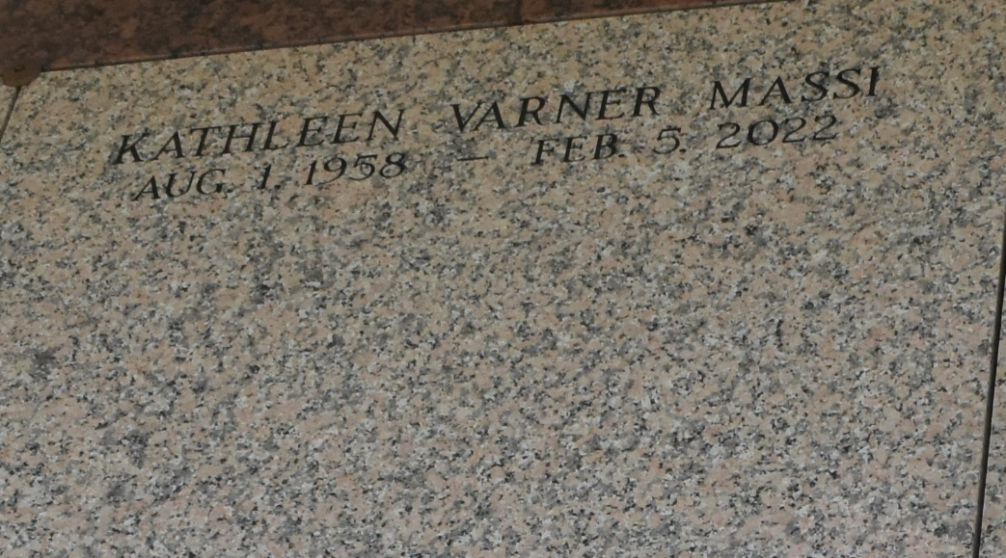

Kathleen Varner Massi the daughter of Gerald Varner and Dixie Varner passed away February 5, 2022. She was the oldest of 8 children.
She was preceded in death by her father Gerald Varner. She is survived by her mother Dixie and 7 younger siblings Jeri, Barbara, Gerald, Mike, Patricia, Mark, Elizabeth and one son Bobbie. She was also survived by a slew of nieces, nephews, great nieces and nephews, and a special mother-in-law Dot.
She was well versed in travel as she grew up as a child of a father who was in the military. Majority of her childhood was spent in Tucson, Arizona. She made a lasting impression on all who knew her and she will be missed.
A Private Graveside Service was already held. Arrangements by Millet-Guidry Funeral Home. To share memories or condolences, please visit www.milletguidry.com.
Obituary published on Legacy.com by
Millet-Guidry Funeral Home, LaPlace, Louisiana
Feb. 9, 2022

