- Grace (Moore) Matherne
January 5, 1939 – July 8, 1995

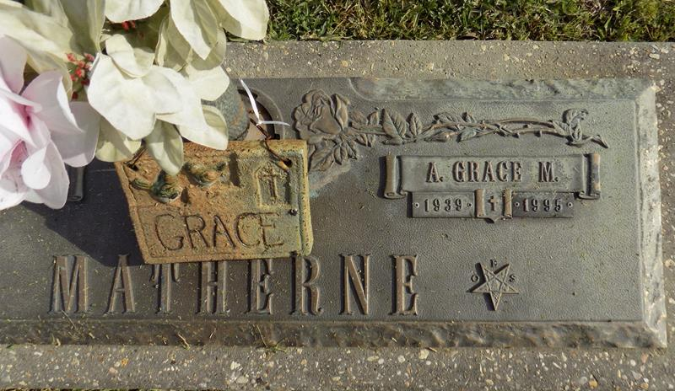

A. GRACE MATHERNE ON SATURDAY, JULY 8, 1995 AT 9:14 A.M. BELOVED WIFE OF DOUGLAS MATHERNE. MOTHER OF LASONYA JENSEN, LAVONA CLEMENT AND LADONNA PATTON. MOTHER IN LAW OF ROBERT JENSEN, SR., KELLY PATTON AND RICKEY MILLET. GRANDMOTHER OF GRACE, KRISTIN, KASIE, ROBERT, JR., KATIE AND WHITNEY. DAUGHTER OF MARY MOORE AND THE LATE JAMES E. MOORE. SISTER OF TIP AND JOY LYNN MOORE. DAUGHTER-IN-LAW OF LISE AND SIDNEY MATHERNE, SR. SISTER-IN-LAW TO SJ & AMBER, PHIL & JUNE, ALLEN & JODY MATHERNE, GORDON & GLORIA TAMPLAIN, PAUL & NOREEN CHAMPAGNE, CONRAD & PATTY BAKER. AGE 56 YEARS. A NATIVE OF TEXAS AND A RESIDENT OF LAPLACE FOR THE PAST 25 YEARS.
RELATIVES AND FRIENDS OF THE FAMILY ARE INVITED TO ATTEND THE FUNERAL. SERVICES AT MILLET-GUIDRY FUNERAL HOME, 2806 WEST AIRLINE HWY, LAPLACE, LA ON TUESDAY, JULY 11,1995. FOLLOWED BY RELIGIOUS SERVICES AT ASCENSION OF OUR LORD CATHOLIC CHURCH, LAPLACE, LA AT 10:00 A.M. INTERNENT IN ST JOHN MEMORIAL CEMETERY, LAPLACE, LA. FRIENDS MAY CALL FROM 5:00 P.M. UNTIL 10:00 P.M. ON MONDAY. (RECITATION OF THE ROSARY AT 7:00 PM BY THE 4TH DEGREE KNIGHTS OF COLUMBUS) AND FROM 8:00 A.M. UNTIL SERVICES ON TUESDAY. IN LIEU OF FLOWERS, DONATIONS PREFERRED TO THE ASCENSION ADERATION CHAPEL.
Unknown source
Contributed by Lavona Millet

