Sidney John Matherne Jr.
February 16, 1941 - December 13, 2018

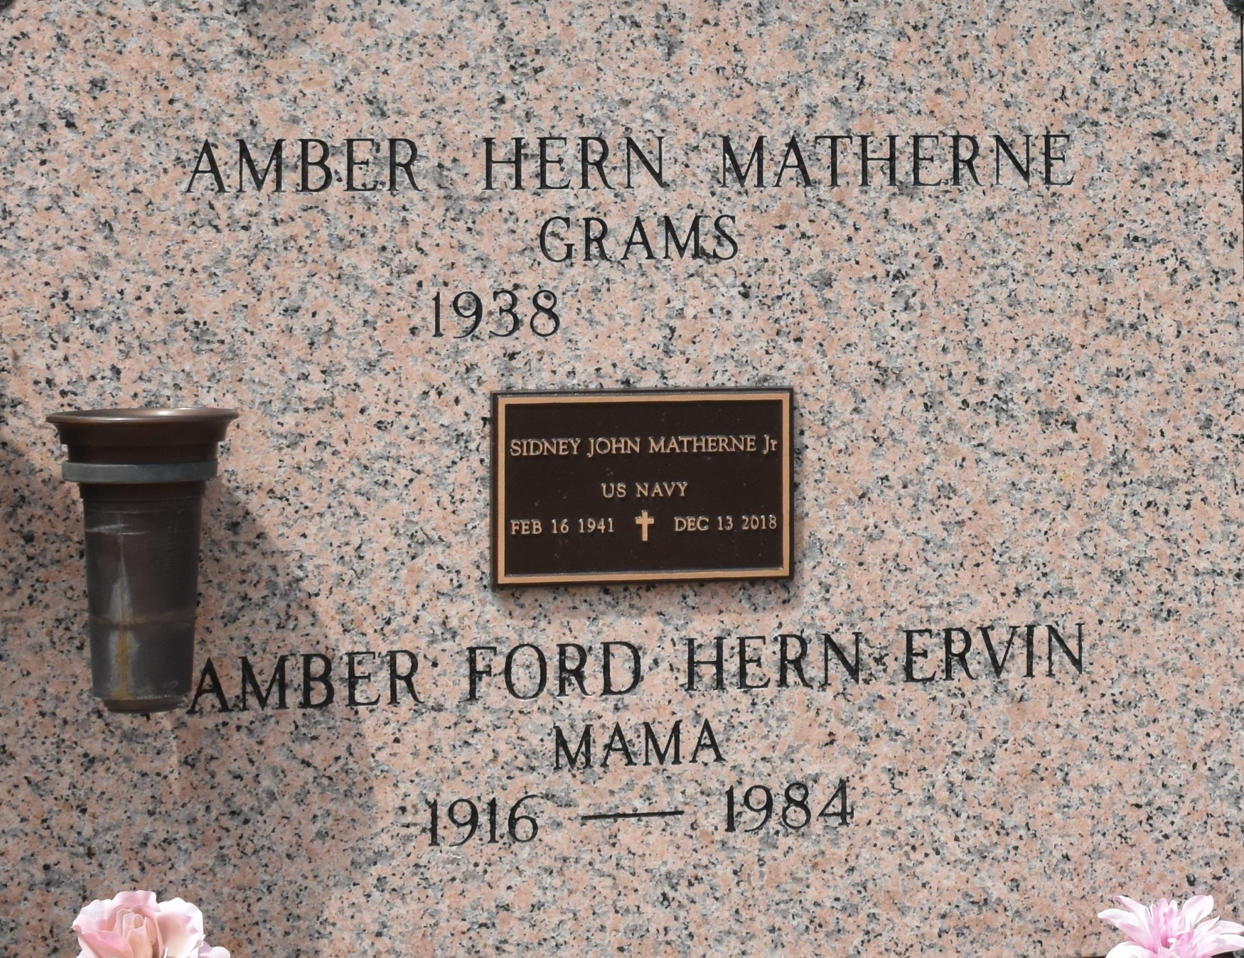

S. J. Matherne Jr., a US Navy Veteran, passed away on Thursday, December 13, 2018. He was 77, born in New Orleans, LA and was a resident of LaPlace, LA. He was survived by his beloved wife, Amber Hern Matherne. His children, Betsy Ragan (Jim), Lori Ramsey (Jesse), Amber Gordon (David) and John Matherne. His 8 grandchildren and 5 great-grandchildren. His siblings, Douglas Matherne (Gerry), Phil Matherne (June), Allen Matherne (Jody), Gloria Tamplain (Gordon), Noreen Champagne and Patty Baker (Conrad).
He was preceded in death by his grandson, Joshua Ramsey. His parents, Lise Tassin Matherne and Sidney J. Matherne Sr. His sister-in-law, Grace Matherne and his brother-in-law Paul Champagne.
Relatives and friends are invited to attend the Funeral Mass at Millet-Guidry Funeral Home, 2806 W. Airline Hwy., LaPlace on Tuesday, December 18, 2018 at 12:30 p.m. Visitation from 10:00 a.m. until 12:30 p.m. Interment in St. John Memorial Gardens Cemetery.

Millet-Guidry Funeral Home, LaPlace, Louisiana
December 15, 2018

