Alice Mae (Montz) Maurin
October 30, 1920 – August 21, 2001
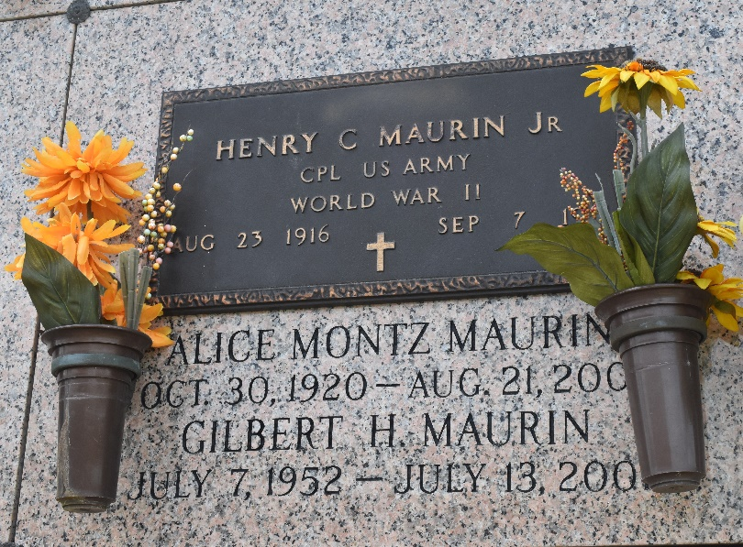
Alice Mae Montz Maurin, 80, a native and resident of LaPlace, died Aug. 21. She was the wife of the late Henry "Foot" Maurin Jr. and mother of Gary, Greg "Za" and the late Gilbert Maurin. She was the daughter of the late Armand Sr. and Aline Montz Maurin and sister of Armand Jr. and Nem Montz. She is survived by seven grandchildren and one great-grandchild. She was a retired elementary school teacher.
Services were Aug. 23 at St. Joan of Arc Catholic Church, LaPlace, with interment at St. John Memorial Gardens.
L'Observateur, LaPlace, Louisiana
August 25, 2001

