Douglas McBride
March 12, 1950 – March 1, 2010

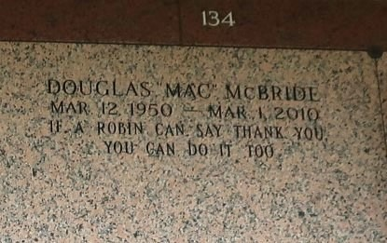

Douglas (Pee-Wee) McBride, a native of Donaldsonville, LA and a resident of Reserve, LA, departed this life on Monday, March 1, 2010 at River Parishes Hospital.
Son of the late Wallace Rodrigue and Gladys Gray. Former husband of Carmen Johson Borne. Father of Denise and Shenita McBride. Brother of Gladys, Loretta (Mick), Nora (Oliver) and Sammy (Regina). Survived by 6 grandchildren, a host of nieces, nephews, cousins, and friends. Age 59 years.
Relatives and friends of the family, also pastors, officers and members of Greater New Plymouth Rock B.C., Mt. Triumph B.C. and neighboring churches; and members of the Tones of Joy Quartet are invited to attend the Funeral Services on Sunday, March 7, 2010 at 7:00 p.m. from the Greater New Plymouth Rock Baptist Church, N.W. 13th St., Reserve, LA. Interment St. John Memorial Gardens, LaPlace, LA. Dismissal Service on Monday, March 8th at 10:00 a.m. Visitation on Sunday at the Church after 5:00 p.m. and Monday after 9:00 a.m. THE BALONEY FUNERAL HOME, LLC 399 Earl Baloney Dr., Garyville, LA 70051 Information: (985) 535-2540 In Charge of Arrangements
The Times-Picayune, New Orleans, Louisiana
Mar. 7, 2010

