Margie Christine (Jones) McDuffie
January 14, 1928 – December 26, 2015
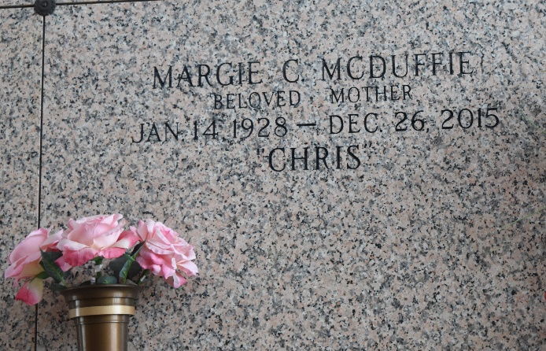

Margie Christine 'Chris' McDuffie, age 87, passed from this earth to God's Heavenly Home on Saturday, December 26, 2015. Beloved wife of the late Lonnie T. Mc Duffie for 55 years. She was preceded in death by her parents, Martha Jones and Dewey Jones; her brother, Dewey 'Bud' Jones, Jr.; and her sister, Vera Wilson. Mother of Jerry, Terry, and Richard Mc Duffie and Diane Reed. Grandmother of Matt, Rusty, Troy, Chris, Scott, Travis and Shannon and step grandmother of Travis, Christy, Kathy, Tommy and Annette. Great grandmother of Ashley, Dalton, Austin, Kati, Karson, Tyler and step great grandmother of Josh. Great-great grandmother of Link.
She was born January 14, 1928 in DeQueen, AR. She married and became a career military housewife raising four children. After her husband’s service career she became a resident of Louisiana in 1957 until her death. She lived in Destrehan for several years before becoming a resident of LaPlace for the past 42 years. She and Lonnie enjoyed traveling in their motor home around the U.S. and Canada. Her greatest pleasure was playing bingo and best of all weekly poker games with family and friends. She loved to crochet and give out pieces for gifts. It is with great sorrow that we see her depart this earth, but we will celebrate her life knowing God has a better place for us all.
Visitation was held at Millet-Guidry Funeral Home, 2806 W. Airline Hwy., LaPlace, on Thursday, December 31, 2015 from 9:00 a.m. to 12:00 p.m. with the Funeral Service at 12:00 p.m. Interment was in St. John Memorial Gardens Cemetery, LaPlace.

The New Orleans Advocate, Louisiana
Dec. 28, 2015 to Jan. 2, 2016

