Lucus Darvin McGuffy Sr.
December 1, 1964 – September 13, 2020

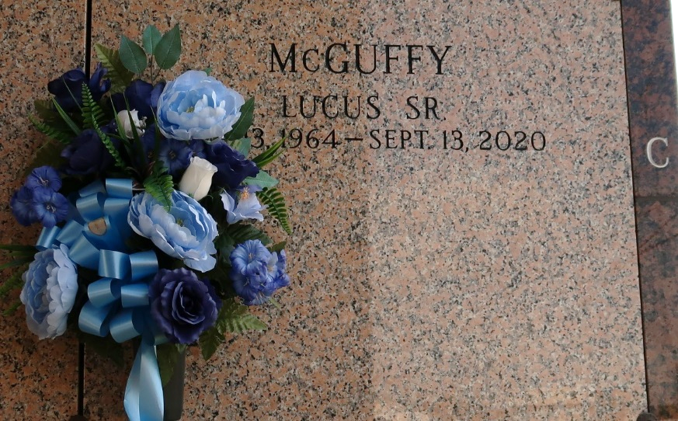

Lucus Darvin McGuffy departed this life at Ochsner Main Campus in Jefferson, LA on Saturday, September 13, 2020. He was born on December 1, 1964 to Lawrence McGuffy and Lizzie Robinson McGuffy. Lucus accepted Christ at an early age and was baptized by the late Rev. Joe Saud at St. Joe Baptist Church. He later joined St. Mark Baptist Church in Mt. Airy, LA, Pastored by Rev Oscar Nelson. Lucus was a 1985 graduate of East St. John High School. Lucus was employed by Wal-Mart in Laplace, LA for the past 10 years where he worked diligently until his untimely death. He was a loyal New England Patriots fan and enjoyed spending time with his family. His smile would light up any room. His favorite song was “A Sinner's Prayer". He loved watching old TV shows. Two of his favorites were 6 Million Dollar Man and Bigfoot.
Lucus leaves to cherish his precious memories his loving wife Latasha McGuffy, children Lukeisha, Lucus Jr. and Aaliyah McGuffy, two stepchildren Africa and Dionte Davis, three grandchildren Ahmad Davis, Carter Davis and Ahvant Fredricks, his loving parents Lawrence Sr. and Lizzie McGuffy, siblings Lawrence McGuffy, Jr., Loren (Wanda) McGuffy, Leonard McGuffy, Sr., Leslie (Gerald) Knight, Larissa (Edward) Scott, and Ann Marie (Romalash) Craighead, father and mother-in-law Sammy, Sr. and Regina Johnson-Gray, brother-in-law Sammie Gray, III and sister-in-law Yolanda Gray, aunts Lillie Mae Taylor, Aldonia Smith, Augustine and Alice Robertson, uncle Jimmy Robertson, god-children Shondrika Isom Brown, Dehshondra Robertson and A'mari Craighead, his prayer partner/cousin Pamela Gibson and host of nieces, nephews, cousins and friends.
Lucus was preceded in death by his grandparents Eddie and Lizzie Robertson and George and Carrie McGuffy, Sr., grandchild Cartel Davis, aunt Otha Mae McGuffy, uncles Willie and Wilbert Brown, George and Hubert McGuffy and Eddie Robertson.
Relatives, Friends, Wal-Mart staff, and All neighboring churches are invited to a Celebration of his wonderful life on Saturday, September 19, 200 located at Treasures of Life Funeral Services, 315 E. Airline Highway, Gramercy, LA 70052 for 11:00 am. Visitation will begin at 9:00 am. Entombment to follow at St. John Memorial Gardens, Laplace, LA. Final care entrusted to Treasures of Life Funeral Services, 315 E. Airline Highway, Gramercy, LA 70052.

The Times-Picayune, New Orleans, Louisiana
Sep. 17 to Sep. 19, 2020

