Alice S. McGuire
October 7, 1921 – July 15, 2015
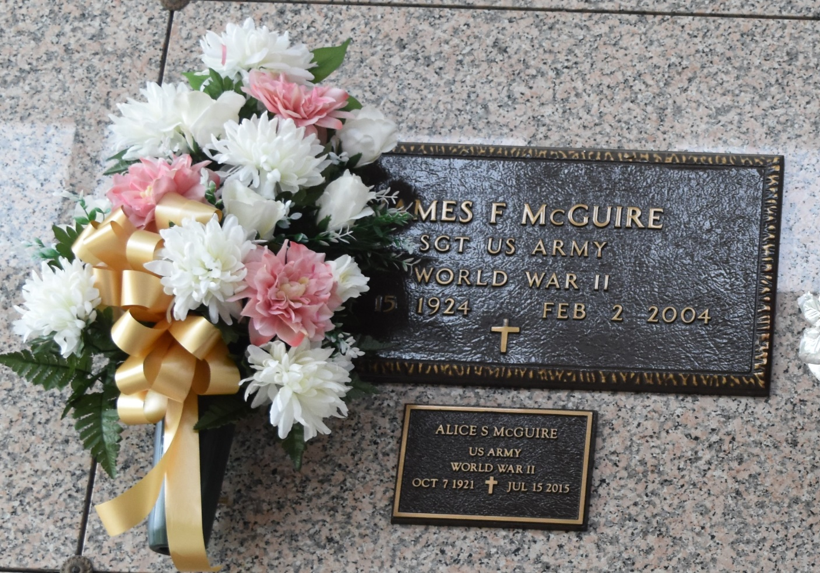

Alice Scioneaux McGuire passed away on Wednesday, July 15, 2015. She was 93, a native of Vacherie and a resident of LaPlace, LA. Beloved wife of the late James F. McGuire. Mother of Richard McGuire, Patricia Nichols and Carolyn Madere. Daughter of the late Wilson and Eva Scioneaux. Sister of Hazel S. Roche, Olga S. Englade and the late Wilson 'Toot' Scioneaux, Jr., Edwin Scioneaux and Nelva S. Oncale. Grandmother of Holly Hymel, Clayton Madere, Amanda Hayes, Tiffani McGuire and Chris Nichols. Also survived by 7 great-grandchildren.
Relatives and friends are invited to attend the Funeral Service at Millet-Guidry Funeral Home, 2806 W. Airline Hwy., LaPlace, LA on Friday, July 17, 2015 at 10:30 a.m. Visitation from 9:00 a.m. until 10:30 a.m. Interment in St. John Memorial Gardens Cemetery. To view or sign the online guest book, please visit www.milletguidry.com.

The Times-Picayune, New Orleans, Louisiana
July 16 to 17, 2015

