James F. McGuire
May 15, 1924 – February 2, 2004
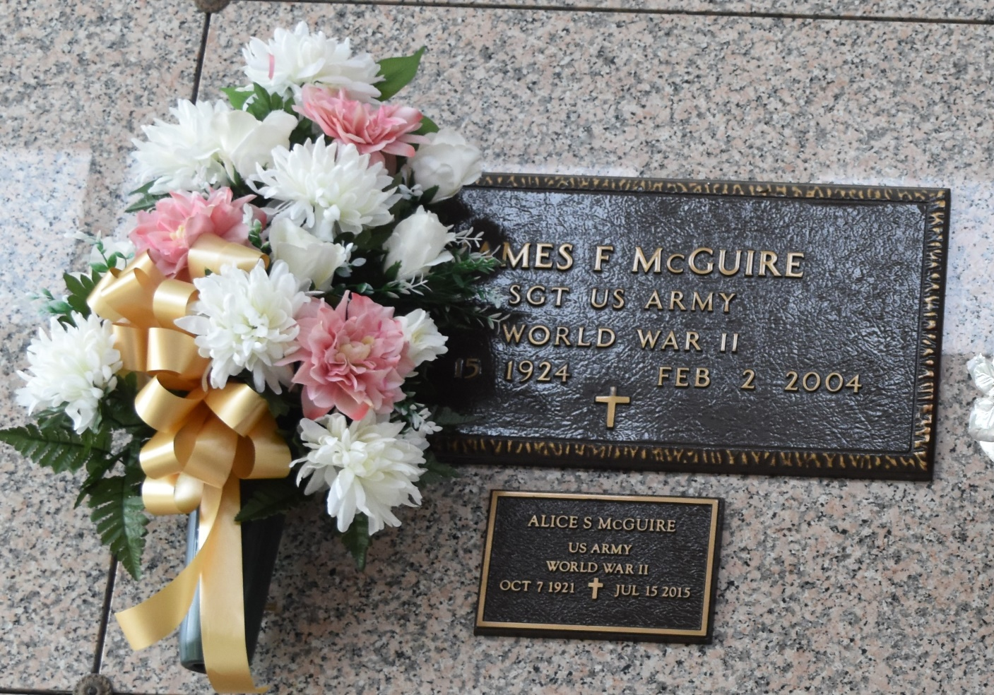

James F. McGuire on Monday February 2, 2004 at 1:40 PM. Beloved husband of Alice Scioneaux McGuire. Father of Richard McGuire, Pat Nichols and Carolyn Madere. Grandfather of Holly Hymel, Clayton and Amanda Madere, Tiffani McGuire and Chris Nichols. Also survived by 4 great- grandchildren. Son of the late Thomas and Willie McGuire. Brother of William and Gerald McGuire, Mary DePoister, Marcy Johnson, June Speighps, Neva Smith, Martha Finnmen and also the late Willie Mae Blalock. Age 79. A native of Tennessee and resident of Reserve for the past 37 years.
Relatives and friends of the family are invited to attend services. Visitation at MILLET-GUIDRY FUNERAL HOME, 2806 West Airline Hwy., LaPlace on Thursday February 5 from 9 AM to 11 AM. Followed by religious services in the funeral home chapel at 11 AM. Burial in St. John Memorial Gardens Cemetery, LaPlace.

The Times-Picayune, New Orleans, Louisiana
February 4, 2004

