Susan Ann Tabb McIntosh
June 24, 1951 - April 15, 2024

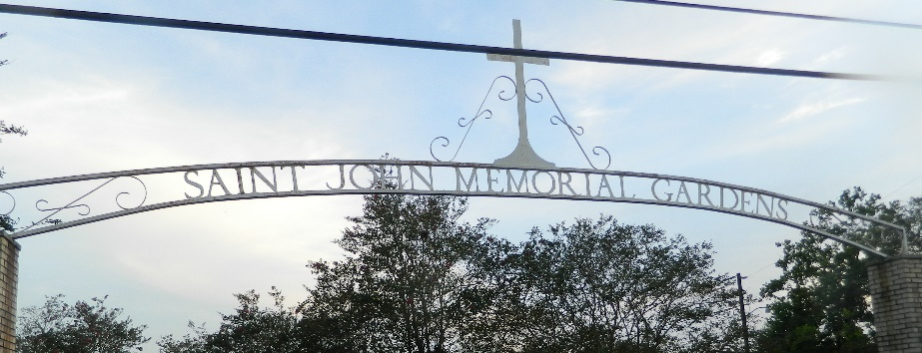

Susan Ann Tabb McIntosh passed away on Monday, April 15, 2024 at the age of 72. She was a native of Lutcher and resident of LaPlace. Susan loved to play bingo and cards.
Beloved wife of Terry Joe McIntosh, Sr. Loving mother of Carl Tabb (Wendy), Malinda Windham (Justin), Tommy Ecroyd (Michelle), Joann Reeves (Clifton), Christina Tabb, and Michael McIntosh (Madison). Step-mother of Terry Joe McIntosh, Jr. (Ashlynne). Grandmother of Tabitha Tabb, Taylor Tabb, Kevin Tabb, Hunter Tabb, Shelby Ecroyd, Bailey Ecroyd, Kailey Ecroyd, Brayden Debowes, Jillian Cazes, Raylan Reeves, Vivian Reeves, Blair Turner, Dillon Turner, Jr., Harvey McIntosh, and Brooks McIntosh.
Daughter of the late Allen Tabb, Jr. and Nora Duhe Tabb. Sister of Allen Tabb, III (Brenda), Wilfred Tabb, Patrick Tabb (Donna), Christopher Tabb, Kathleen Reine, Loretta Jouty (James), Belinda Donis (Patrick) and the late Debra Matthews. Also survived by many nieces and nephews and her beloved dog, Bella.
Relatives and friends are invited to attend the Visitation and Funeral Service at Millet-Guidry Funeral Home, 2806 W. Airline Hwy, LaPlace. Visitation will be held Thursday, April 18, 2024 from 5:00 p.m. to 8:00 p.m. and Friday, April 19, 2024 from 9:30 a.m. to 11:30 a.m. with the Funeral Service to immediately follow the visitation at 11:30 a.m. Interment in St. John Memorial Gardens Cemetery.

Millet-Guidry Funeral Home, LaPlace, Louisiana
APRIL 17, 2024

