John Blaine McKnight

December 30, 1954 – June 10, 2012

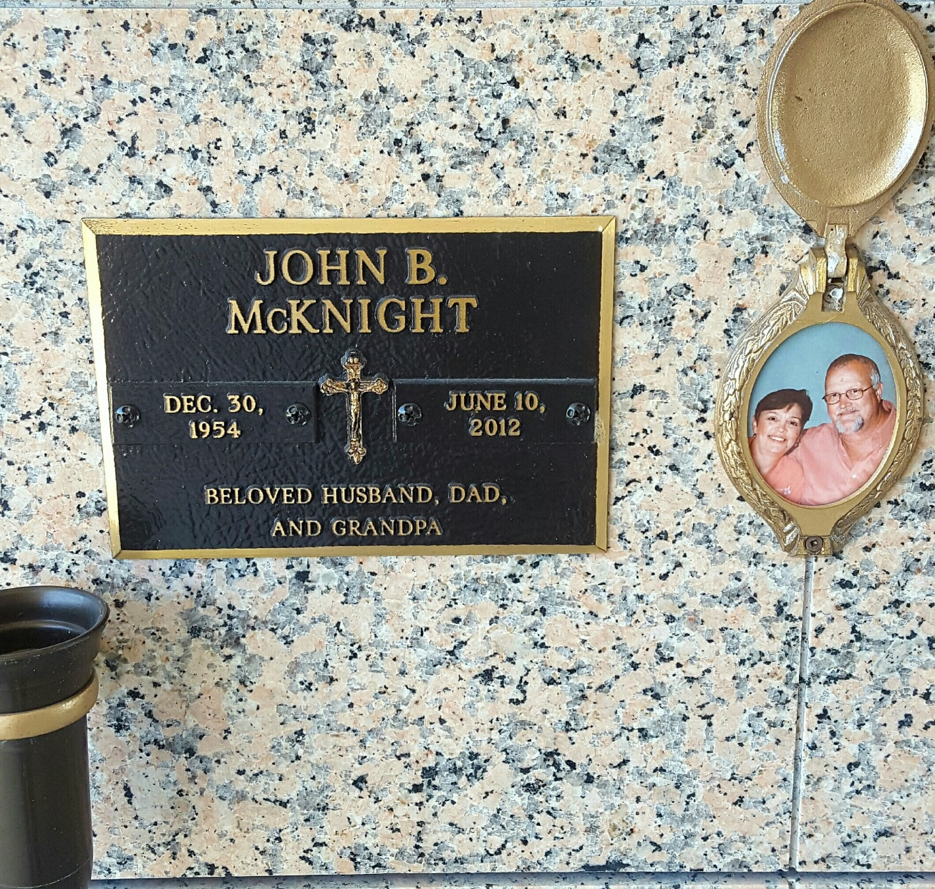

Photo by MBC

John Blaine McKnight, beloved husband of 37 years of Ann Schexnayder McKnight, passed away peacefully at Canon Hospice on Sunday June 10, 2012. Loving father of Jeremy (Victoria) and Andrew McKnight. Proud Grandpa of Olivia, Jeremy John, and Dalton McKnight. Brother of Scott (Judi) and Bruce (Robert) McKnight, and the late Bradley (Jeanne) and James McKnight. Uncle of Danniele, James and Janna Rose McKnight, and as Big John to nieces Lindy (Andy) Smith, Christa (Greg) Veillon, and Shelley Schexnayder. Devoted son of the late Othar and Virginia McKnight, age 57, and a resident of La Place for 42 years. Retired from Shell/Motiva in Norco.

Relatives and friends of the family are invited to attend the Funeral Mass at St. Joan of Arc Catholic Church in La Place at 11:00 AM on Wednesday, June 13, 2012. Visitation at Millet-Guidry Funeral Home from 8:30 AM until 10:30 AM. Internment will be private. In lieu of flowers, donations to Get High on Life, P.O. Drawer U, Reserve, LA 70084, are preferred.

The Times-Picayune, New Orleans, Louisiana

Jun. 11 to Jun. 13, 2012