Willie James McKnight
August 5, 1921 - March 1, 2023

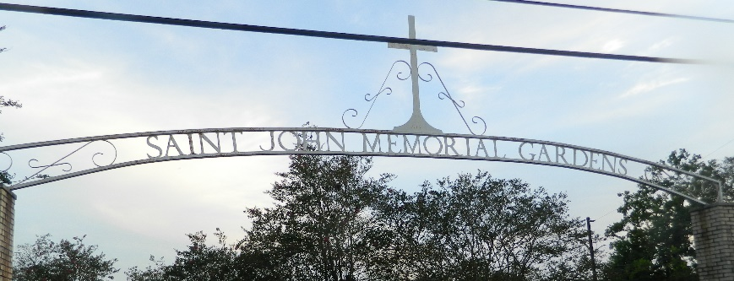

On Wednesday, March 1, 2023 at 07:50AM our late Brother Willie James “Mack” McKnight fell asleep. He crossed over to glory peacefully at his home in Kenner, LA surrounded by his loving family.
Willie James “Mack” McKnight Sr. was born on August 5, 1921 to the union of the late Emmanuel and Rhoda Eli McKnight of Ethel, LA.
Willie grew up in Ethel, Louisiana where he received his secular education in the East Feliciana Parish Public School System. Later, he enlisted in the United States Air Force where he successfully served six years and received an Honorable Discharge. In 1940, Willie married the late Mary Westbrook and to this union are three children Will McKnight, Janice McKnight Carter, and Kenneth McKnight, 8 grandchildren, 9 great grandchildren and 1 great great grandchild.
In 1996, he married his 2nd wife Carolyn Mitchell McKnight. They remained married for the last 26 years and thru this union he gained three (3) bonus step-daughters, Antoinette Pickett, Sawuan Noel, San Rixner and a bonus son, Curtis Edwards, six (6) bonus grandchildren, and eight (8) bonus great-grandchildren.
Willie was employed with the Jefferson Parish department of water for ten (10) years; Schwegmann’s Grocery Store for thirty-five (35) years and Burlington Coat Factory for three (3) years before retiring.
He really enjoyed fishing, hunting, and going to church. He was a faithful usher for thirty (30) plus years at Second Free Mission Baptist Church and Greater New Plymouth Rock Baptist church. Later, Willie became a faithful disciple and tither for Jesus Christ at Second Mt. Carmel Missionary Baptist Church in Sorrento, LA, under the leadership of his Son-In-Love, Pastor Donald Rixner Jr, and his bonus/stepdaughter, 1st Lady San Rixner.
His favorite sayings were, “You may be the oldest, but I got here first,” and “You get what you pay for Carolyn.”
Willie leaves to cherish his memories his beloved wife, Carolyn McKnight of Kenner, Louisiana; two sons, and one daughter, Will McKnight (Marie), of Moscow, Tennessee; Kenneth McKnight (Adrienne) of Kenner, Louisiana; Janice Carter (widowed) of Metairie, Louisiana. Three bonus, daughters, Antoinette Pickett (Lawrence) of Junction City, Kansas, Sawuan, Noel (Yvel) of Saint Paul, Minnesota; and San Rixner (Donald Jr.) of LaPlace Louisiana. One bonus son, Curtis Edwards(Beatrice), of Laplace, LA. Eight (8) grandchildren, nine (9) great grandchildren, 1 great, great grandchild. Six bonus grandchildren, and eight bonus great-grandchildren. Also, his three dear friends, Charles Miller, Roland Leblanc, and Malcom Songy. He also leaves a host of nieces, nephews, cousins, and friends.
He was preceded in death by his parents, Emmanuel and Rhoda Eli McKnight, his four sisters Rozella McKnight, Gladys Hilliard, Beatrice Harris, Plier Atkins, and one brother, Fred McKnight, Sr., his niece, Diane Davis, a great nephew, Terry Matthews.
Relatives and friends of the family, Pastors, Officers and Members of Second Mt. Carmel Missionary Baptist Church in Sorrento, LA. and all surrounding churches are invited to a Home Going Celebration at 11:00 am on Saturday, March 11, 2023 at Second Mt. Carmel Missionary Baptist Church, 8372 Railroad Avenue, Sorrento, LA 70778. Rev. Donald Rixner, Pastor-Officiant. Visitation 9:00 am until time of service at the above-named location. Interment St. John Memorial Gardens, 2205 W. Airline Hwy, LaPlace, LA 70068. There will be a public visitation from 4:00pm to 6:00pm on Friday, March 10, 2023 at the Patrick H. Sanders Funeral Home, 605 Main Street, LaPlace, LA 70068.

Patrick H. Sanders Funeral Home, LaPlace, Louisiana

