James R. McTopy Jr.
February 25, 1953 – December 6, 2013
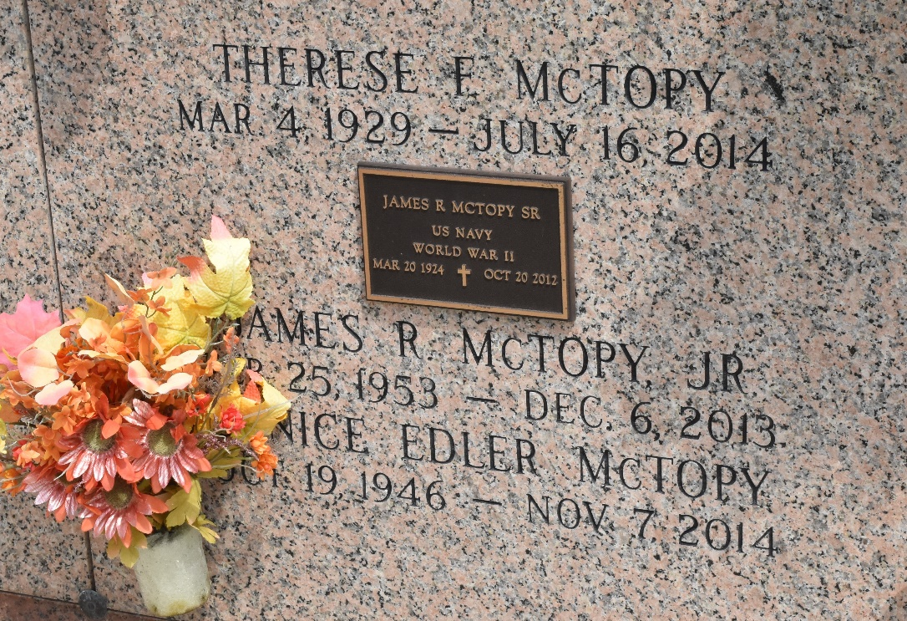

James “Jay” “Lil Mac” McTopy Jr., 60, died on Friday Dec. 6, 2013.
He was the beloved husband of Janice Edler McTopy, son of Therese Faucheux Mctopy and the late James “J.R.” Mctopy Sr. and brother of Margaret M. Munoz, Debbie M. Frederiksen (Michael) and Jill M. Granier (Johnny). He is also survived by six nephews and two great nieces. He was a native and resident of LaPlace.
Relatives and friends are invited to attend services. Visitation will be held at Millet-Guidry Funeral Home, 2806 W. Airline Highway, LaPlace, on Wednesday, Dec. 11, 2013, from 8 a.m. to 9:30 a.m., followed by Mass at St. Joan of Arc Catholic Church in LaPlace at 10 a.m. There will be a private burial at a later date.
L’Observateur, LaPlace, Louisiana
Tuesday, December 10, 2013

