John W. McTopy
June 24, 1913 – October 5, 1999
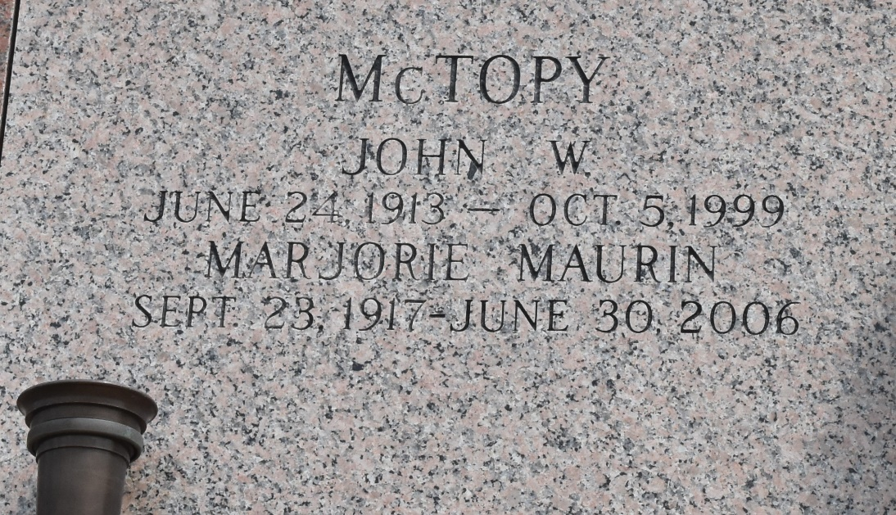

LAPLACE - John "Johnny Mac" McTopy, 86, a native of Garyville and a resident of LaPlace for 70 years, died Oct. 5.

He was the husband of Marjorie Maurin McTopy and father of John II, Joel and Brian McTopy. He was also the brother of Edna Mae Bruce, Gloria Mason, J.R. and Donald McTopy, and the late Mary Ellen Buras, Nolan, Lolan and Earl Badeaux. He is also survived by 10 grandchildren and 10 great-grandchildren.

Services were held Oct. 8 in the chapel of Millet-Guidry Funeral Home, LaPlace, with interment at St. John Memorial Gardens, LaPlace.
L'Observateur, LaPlace, Louisiana
October 11, 1999

