Marjorie (Maurin) McTopy
September 23, 1917 – June 30, 2006
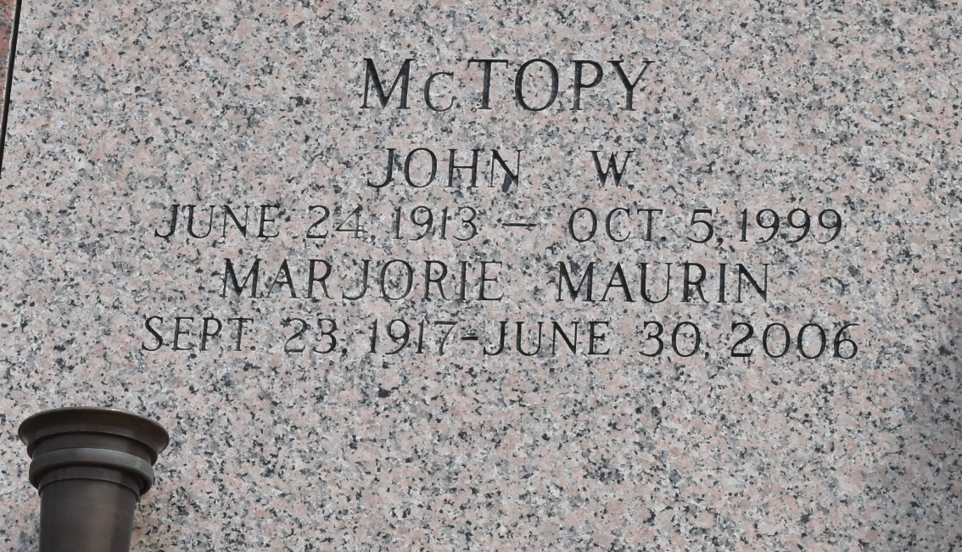
Marjorie Maurin McTopy on Friday, June 30, 2006 at 11:40 p.m. Beloved wife of the late John McTopy. Mother of John II and Brian McTopy and also the late Joel McTopy. Also survived by 11 grandchildren, 17 great-grandchildren and 1 great-great-grandchild. Daughter of the late Louis and Emma LeBrun Maurin. Sister of Elaine Delaneuville, Marie Therese Montz and the late Louis Jr. (L.J.) and LeBrun Maurin, Gloria Oubre and Jo-Anne (Jody) Montz. Age 88 years. A native of Reserve, LA and a resident of LaPlace, LA for the past 68 years.
Relatives and friends of the family are invited to attend services. Visitation at MILLET-GUIDRY FUNERAL HOME, 2806 W. Airline Hwy., LaPlace, LA on Monday, July 3, 2006 from 10:00 a.m. until 12:00 noon. Followed by Religious Services at the Funeral Home Chapel at 12:00 noon. Burial in St. John Memorial Gardens, LaPlace, LA.
Times-Picayune, The (New Orleans, LA) - Sunday, July 2, 2006
Contributed by Jane Edson

