Terry Jean (Walker) Mckarry
October 9, 1954 – September 16, 2018
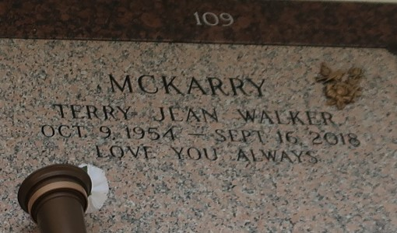

Terry Jean Walker Mckarry, Age 63 Passed away on Sunday, September 16, 2018. Daughter of the late Andrew and Evella Frederick Walker, wife of Marshal Mckarry Jr. Mother of Dawn Simon, Elisar Green, and Marla Mabone, Da'Ziree Walker whom she reared as her own, step- mother to Javis and Gabrelle Mckarry, Sister of Betty Painia, Beverly Gardner, Donald and Patrick Walker, Daughter in law of Easter Mckarry. Terry is survived by grandchildren, great grandchildren, sisters and brothers in laws, nieces, nephews and a host of relatives and friends.
Celebration service on Saturday September 29, 2018 at Greater New Mt. Zion B.C. 101 Historic East St. Garyville, LA 70051 at 11:00 am. Dr. Rev. Wesley Anderson Jr., Pastor Officiating. Interment St. John Memorial, Laplace La. Visitation on Saturday at the church from 9 am until service time. Professional Services entrusted to the caring staff Hobson Brown Funeral Home, 134 Daisy St., Garyville, La 70051, (985) 535-2516.
TheNewOrleansAdvocate.com
Sept. 27 to Sept. 29, 2018

