Rogers Joseph Meche

July 10, 1933 – January 13, 2014

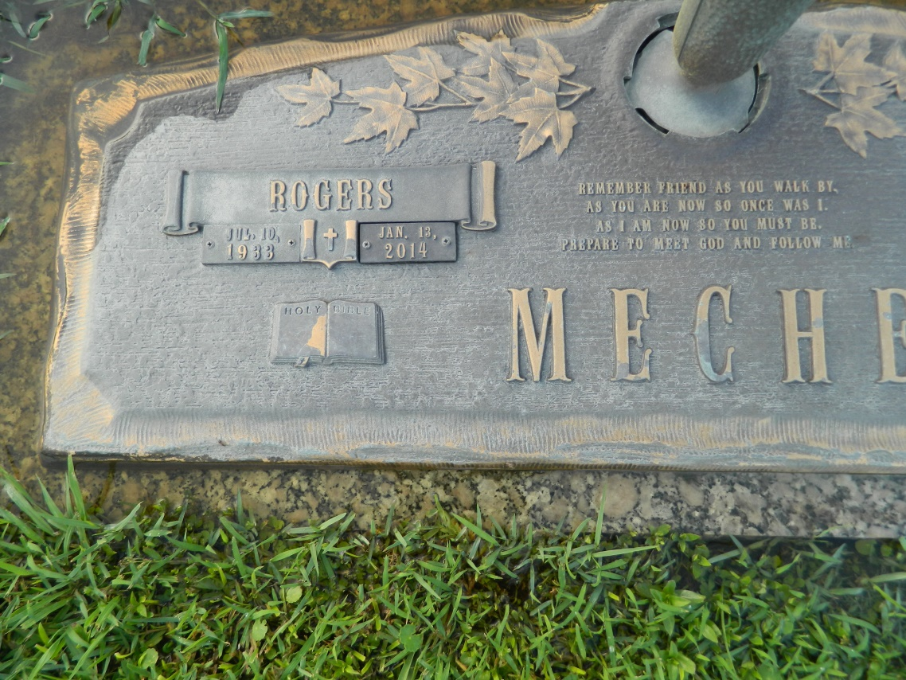

Rogers Joseph Meche, 80, a former resident of LaPlace and a resident of Peachtree City, Ga., passed away Monday, Jan. 13, 2014.  
  
Rogers is survived by his daughter, Chalene Grizzaffi, and her husband, Mark, of Peachtree, three grandchildren: Joshua Brister and his wife, Jessica, of Charlotte, N.C.; Jonathan Brister and Brandi Christian of Peachtree City; and Jordan Brister of Peachtree City. He is also survived by sisters: Elsie Vedrenne and her husband Lee of Opelousas; Zeanne Speyrer of Del Rio, Tenn.; and Uella Leger of Lafayette. Rogers is also survived by numerous nieces, nephews and cousins who loved him dearly.  
  
Funeral services were held on Friday, Jan. 17, 2014, at Millet-Guidry Funeral Home in LaPlace. Burial followed at St. John Memorial Gardens Cemetery in LaPlace.

L'Observateur (La Place, LA) - Friday, January 17, 2014

Contributed by Jane Edson