Melvin J. Melancon
July 22, 1942 – August 10, 2021

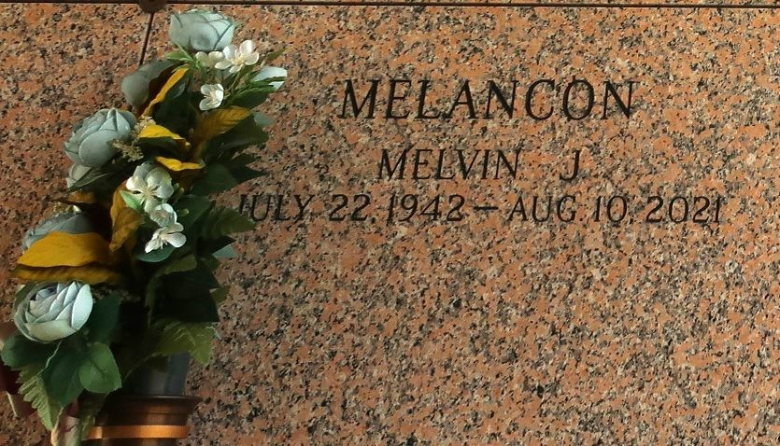

Melvin J. Meloncon 'Mel' died on Tuesday, August 10, 2021 at Ochsner Hospital, Jefferson, Louisiana. Son of the late Viola Gray and Oliver Meloncon. Husband of Barbara Ross Meloncon. Father of Monique Lewis, Jude Meloncon, Kanard Meloncon and James Meloncon. Brother of Barbara Moon and Kevin Meloncon. Also survived by 10 grandchildren, 5 great grandchildren and a host of nieces, nephews, cousins, other relatives and friends. Age 79 years. A native and a resident of LaPlace, LA.
Relatives and friends of the family, also pastors, officers and members of Rising Star Baptist Church and all neighboring churches are invited to attend the funeral service at Rising Star Baptist Church, 620 Cardinal Street, LaPlace, LA on Saturday, August 21, 2021 at 11:00 a.m. Rev. Donald August, Pastor, Officiating. Interment St John Memorial Garden Cemetery, LaPlace, LA. Visitation at the above named church from 9:00am until service time. Following state guidelines for COVID-19 everyone in attendance are required to wear a mask and practice social distancing. Serviced by Robottom.
The Times-Picayune, New Orleans, Louisiana
August 19 to August 21, 2021

