Lawrence J. Messina
May 5, 1936 – March 2, 2008
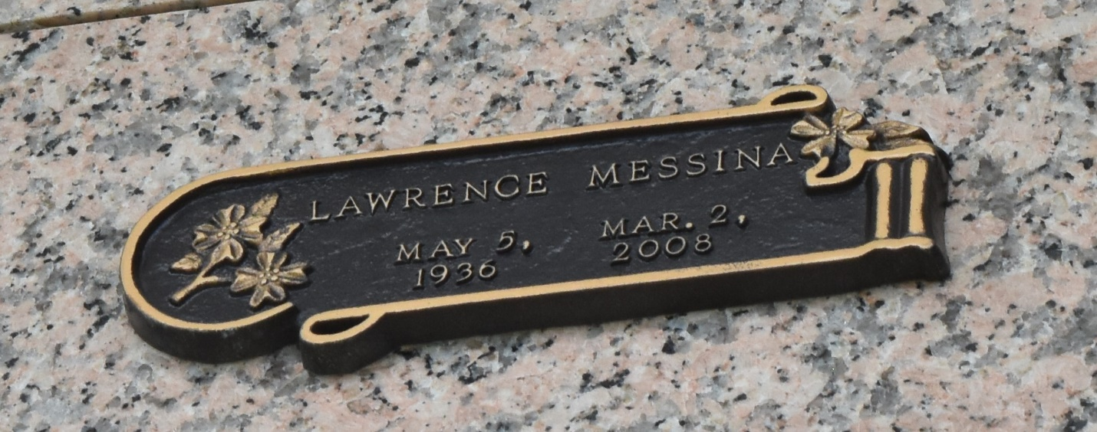

Lawrence J. Messina on Sunday, March 2, 2008 at 1:35pm. Beloved husband of Jean Messina. Son of the late Joseph and Josephine Messina. Brother of Marie DiGiovanni. Uncle of Marcel and Richard DiGiovanni. Great-uncle of Joseph, James, Richard and Megan DiGiovanni. Age 71 years, a native of St. Rose and a resident of LaPlace for the past 10 years.
Services were held at Millet-Guidry Funeral Home, 2806 W. Airline Hwy., LaPlace, La., on Wednesday, March 5, 2008 at 10:30am.
The Times-Picayune, New Orleans, Louisiana
Mar. 6, 2008

