Christopher Charles Metcalf
February 24, 1984 – February 6, 2019
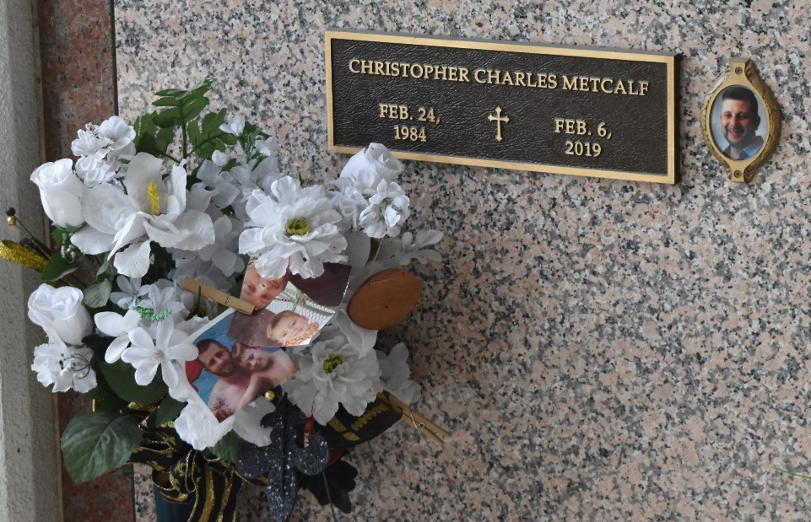

Christopher Charles Metcalf passed away on Wednesday, February 6, 2019 at the age of 34. He was a native and lifelong resident of LaPlace. Loving father of Cayden Charles Metcalf. Beloved son of Robin Metcalf (Chuck Jeandron) and the late Charles Keith Metcalf. Brother of Crystal Kilburn (Sidney) and Christine Stein (Wayne). Also survived by his niece, Charlie; nephews, Drei, Canon and Crew; aunts, Darla Gaudet, Brandy Ronquille and June Scioneaux; cousins, Rusty Gaudet, Jenna Gaudet, Ashleigh Gaudet (Jammi), Cody Scioneaux and Bryce Scioneaux. He was preceded in death by his grandparents and parents, Charles and Patsy Metcalf and Russell Gaudet Jr.
Relatives and friends are invited to attend the Funeral Mass at St. Joan of Arc Catholic Church, 529 W 5th Street, LaPlace, LA on Monday, February 11, 2019 at 12:00 p.m. Visitation at the church from 10:00 a.m. until 12:00 p.m. Interment in St. John Memorial Gardens Cemetery. To view or sign the online guest book, please visit www.milletguidry.com.
In lieu of flowers, the family ask that you donate to Opiod Free America Foundation. This New Jersey based foundation was started by firefighters and other first responders who have seen the tragedy of opioid addiction time and time again. It is dedicated to the education of children ranging from middle school to college students and their parents about the dangers of opioid addiction. Please visit their website www.opioidfreeamerica.org to make a donation so that together we can stop this tragic epidemic.

The New Orleans Advocate, Louisiana
Feb. 7 to Feb. 11, 2019

