Keith Metcalf
July 20, 1964 – November 15, 2007
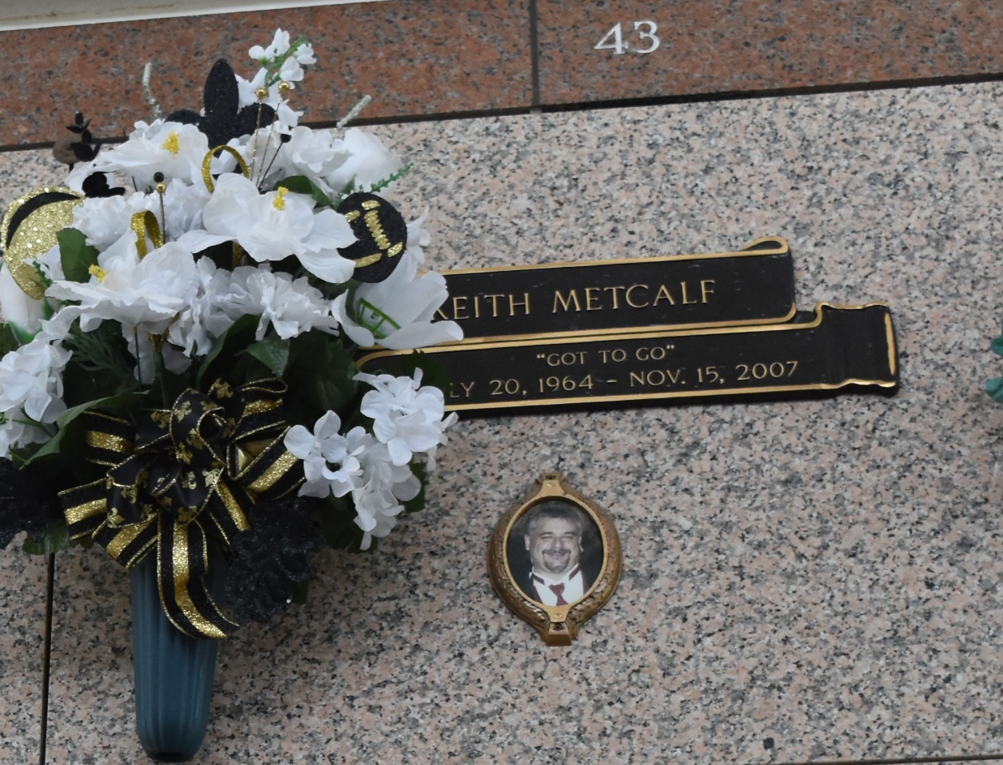

Keith Metcalf on Thursday, November 15, 2007 at 7:22 AM. Beloved husband of Stephenrae Metcalf. Father of Christopher, Crystal and Christine Metcalf. Son of the late Charles and Patsy Metcalf. Brother of Darla Gaudet. Also survived by a nephew and nieces. Age 43 years, A native of Lufkin, Texas and a resident of LaPlace, LA for the past 40 years.
Relatives and friends are invited to attend services. Visitation at Millet-Guidry Funeral Home, 2806 W. Airline Hwy., LaPlace, LA, on Sunday, November 18, 2007 from 5:00 PM to 9:00 PM and on Monday from 8:00 AM to 10:00 AM. Followed by Religious Services at the Funeral Home Chapel at 10:00 AM. Burial in St. John Memorial Gardens Cemetery, LaPlace, LA. In lieu of flowers, donations preferred to the charity of your choice.
The Times-Picayune, New Orleans, Louisiana
Nov. 17, 2007

