Kelly Lynn Meyer
May 12, 1982 - November 24, 2001
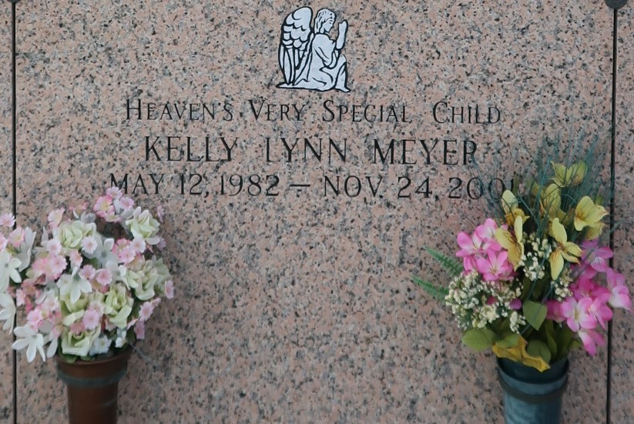

Kelly L. Meyer, 19, a native and resident of Metairie, died Nov. 24. She was the daughter of Jennifer Meyer, formerly of LaPlace, and Tony Meyer, step daughter of Gary Theisges and stepsister of Tammy Theisges. She was the granddaughter of Audrey Prudhomme of LaPlace and the late J.R. "Cha" Prudhomme and Mr. and Mrs. E.J. Meyer.
Services were Nov. 27 in the chapel of Millet-Guidry Funeral Home, LaPlace, with interment at St. John Memorial Gardens, LaPlace.
L'Observateur, LaPlace, Louisiana
November 28, 2001

