Velda Mae (Ordoyne) Michel
October 20, 1937 - May 14, 2020
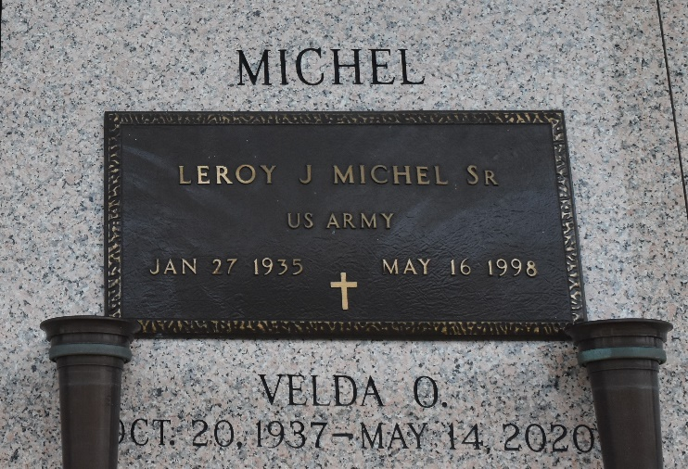

Velda Mae Ordoyne Michel passed away on Thursday, May 14, 2020 at the age of 82. She was a native of Lutcher, LA and a resident of LaPlace, LA.
Beloved wife of the late LeRoy Joseph Michel, Sr. Loving mother of Amy Michel Trosclair (Ricky) and LeRoy “Buster” Michel, Jr. (Rachel). Grandmother of Travis Trosclair (Danielle), Kaitlin Gentry and Hunter Michel. Great grandmother of Isabella Hannon. Daughter of the late Grace Griffin Ordoyne and Alton Ordoyne, Sr. Sister of Beverly “Jean” Davenport, Richard Ordoyne (Jan), and the late Yvonne Cunningham, Alton Ordoyne, Jr. (Linda) and Violet Duhe. Sister-in-law of the late Susan Ordoyne.
Relatives and friends are invited to attend the visitation at St. Joan of Arc Catholic Church, 529 W. 5th Street, LaPlace on Tuesday, May 19, 2020 from 9:00 a.m. to 11:00 a.m. followed by a Funeral Mass at 11:00 a.m. Interment in St. John Memorial Gardens Cemetery. Arrangements by Millet-Guidry Funeral Home.

Millet-Guidry Funeral Home, LaPlace, Louisiana
May 17, 2020

