Fanny Marie (Jones) Miles
May 6, 1962 – August 29, 2008
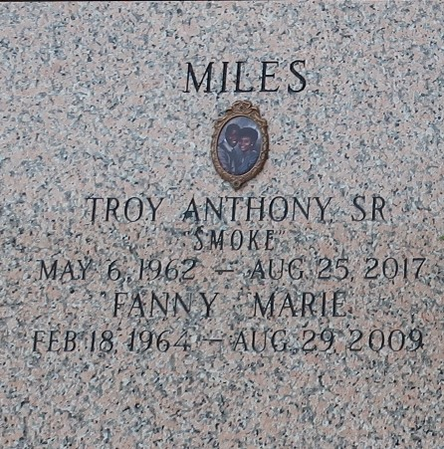

Fanny Jones Miles on Saturday, August 29, 2009 at St. Elizabeth Hospital, Gonzales, LA. Beloved and Devoted wife of Troy A. Miles, Sr. Beloved and Doting mother of Troy A. Miles, Jr. Daughter of Isaiah Jones and the late Elizabeth Willis Jones. Step daughter of Lacy Jones. Sister of Cassandra Jones Jackson and Jennifer A. Jones. Step sister of Jason and Jonas Jones and Paulette Carter. Also survived by a host of nieces, nephews, other relatives and friends. A native of St. John the Baptist Parish.
Relatives and friends of the family, also members of the Congregation of Jehovah's Witnesses, and employees of St. John the Baptist Parish Council and School System are invited to attend the Discourse Services from Kingdom Hall of Jehovah's Witnesses, 500 Colony Park Dr., LaPlace, LA, on Saturday, September 5, 2009 at 11:00 A.M. Interment - St. John Memorial Garden Cemetery, LaPlace, LA. Visitation at the above named Hall from 10:00 am until service time.
In lieu of flowers, please make a donation to the Watch Tower World Wide Work. SERVICED BY ROBOTTOM

The Times-Picayune, New Orleans, Louisiana
September 4, 2009

