Troy Anthony Miles Sr.
May 6, 1962 – August 25, 2017
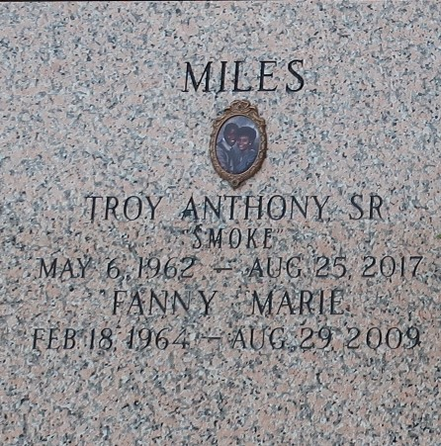

Troy Anthony Miles, Sr. "Smoke," 55, of LaPlace, Louisiana, passed away the evening of Friday, August 25, 2017. Troy is survived by his son, Troy Jr.; his wife Casandra Kimberlain (Philip) Miles; his siblings Ella Mae Johnson, Sandy Miles, Jr., Jessie Miles, Sr., Carolyn Haldane, Gary Miles, Sr., Canera (Cornell) Miles, Prunella Mitchell, Wayne Miles, Veronica Miles, Jeanette Castleberry, Cassandra Kliebert, and a host of nieces and nephews. He was preceded in death by his parents, Sandy and Caroline, sisters Leola Pecos and Pecola Shepard, and his wife of 24 years, Fanny Marie (Jones) Miles in 2009.
Troy was born May 6, 1962, the youngest son to Sandy and Caroline (Coleman) Miles in New Orleans, Louisiana. He was the captain of the boys' basketball team and graduated from East St. John High School in 1981. On August 10, 1985 he married his high school sweetheart, Fanny Jones, in Reserve. Troy was employed as a utilities manager for St. John the Baptist Parish, where he worked for over 25 years. He earned a reputation for being a hard worker who had pride in continuous learning and giving his best.
He was a spiritual man first and foremost, giving up opportunities for collegiate athletics to devote his life to serving God in 1986. He spent most of his weekends imparting Bible knowledge to others through door to door ministry and heartfelt public discourses that drew in every listener with his signature humor and room-filling smile. He proudly served as an elder and the Service Overseer of the Reserve Congregation of Jehovah's Witnesses. He also enjoyed playing and watching sports and riding his motorcycle. On December 17, 2016, he wed his beloved wife Casandra Kimberlain (Philip) Miles. He will be remembered as a loving and devoted husband, father, and spiritual shepherd.
A memorial service will be held at 1:00 pm, Saturday, September 9, 2017 at the Kingdom Hall of Jehovah's Witnesses, 500 Colony Park Dr, LaPlace, LA 70068. Burial will follow at St. John Memorial Gardens in Laplace, LA.
In lieu of flowers, voluntary donations may be made to assist funding worldwide Bible education work at https://apps.jw.org/E_DONATE. Those wishing to sign Troy's guestbook may do so at http://memorial.yourtribute.com/Troy-Miles-Sr/.

The Times-Picayune, New Orleans, Louisiana
Sep. 7 to Sep. 8, 2017

