John Michael Milioto

November 13, 1949 – February 3, 2006

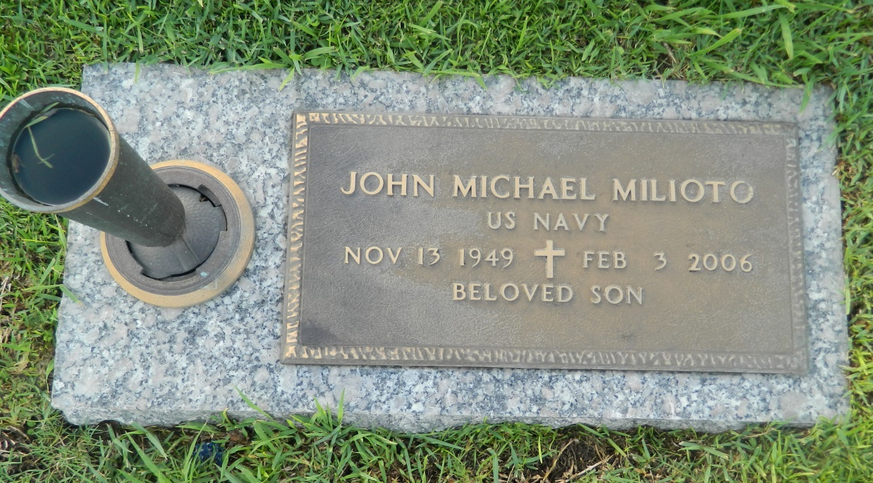

John Michael Milioto, on Friday, February 3, 2006 at 12 Noon. Son of Michael J. and Rita Perilloux Milioto. Brother of Mark and Dominic Milioto. Uncle of Mitch and Misty Milioto. Age 56 years. A native and resident of Laplace, LA.  
  
Relatives and friends of the family are invited to attend funeral services. Visitation at Millet Guidry Funeral Home, 2806 W. Airline Hwy., Laplace, LA. on Wednesday, February 8, 2006 from 8 AM until 10 AM. Followed by religious services at the funeral home chapel at 10 a.m. Interment in St. John Memorial Gardens, Laplace, LA.

Times-Picayune, The (New Orleans, LA) - Tuesday, February 7, 2006

Contributed by Jane Edson