Mark J. Milioto
February 22, 1953 – March 23, 2011
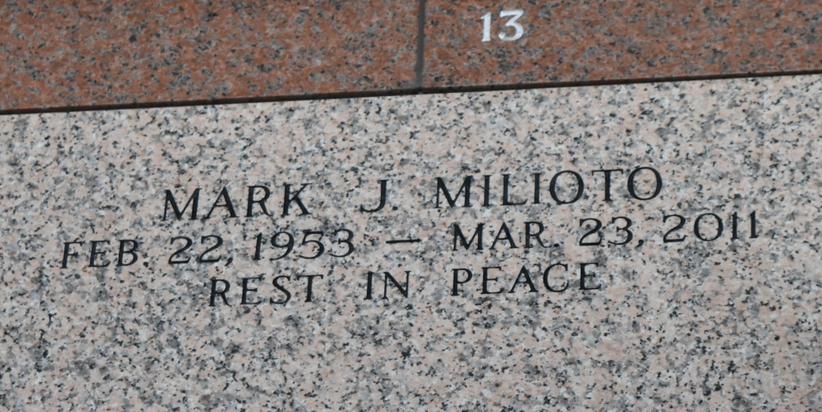

Mark J. Milioto passed away on Wednesday, March 23, 2011.
Beloved son of Rita Perilloux Milioto and the late Michael J. Milioto. Brother of Dominic Milioto and the late John Michael Milioto. Uncle of Mitch and Misty Milioto. Age 58. A native and resident of LaPlace.
Relatives and friends are invited to attend services. Visitation at Millet-Guidry Funeral Home, 2806 W. Airline Hwy., LaPlace, La., on Friday, March 25, 2011 from 12:00 Noon to 1:00 PM followed by Religious Services in the Funeral Home Chapel at 1:00 PM. Burial in St. John Memorial Gardens Cemetery LaPlace, La.

The Times-Picayune, New Orleans, Louisiana
March 24, 2011

