Pamela (Collins) Milioto
June 23, 1950 – November 3, 2019
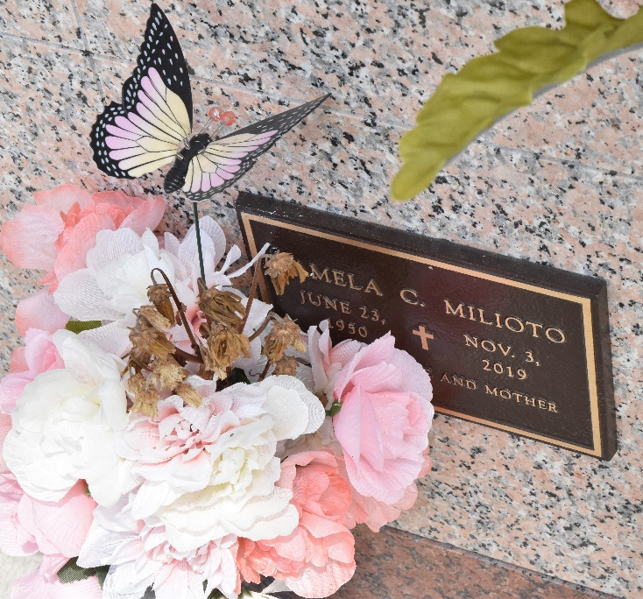

Pamela Ann Milioto, age 69, of LaPlace, LA passed away on November 3, 2019 at her home surrounded by family. Pamela was born in New Orleans, LA on June 23, 1950. Pamela was the daughter of the late William and Florence Collins. She was happily married to John Carl Milioto of 49 years on March 21, 1970.
Pamela enjoyed spending time with her family. She enjoyed quality time outdoors with her husband planting vegetables and fishing. Pamela was a practicing Catholic who religiously went to church on Sunday and said her rosary daily. She had a heart of gold; she was a kind and compassionate person.
Pamela is preceded in death by her parents, William and Florence Collins; her sisters, Noel Ward, Sharon Reech (James); her brother, Charles Collins; and her brother-in-law, Stephen Milioto.
She is survived by her husband, John Carl Milioto; her children, Chrissy Wilcox (Joey), Holly Agurcia (Carl) and John Carl Milioto, Jr.; her twin sister, Billie Naquin (Joseph); her sister, Patricia Collins; and her grandchildren, Holden Loper, Carley Wilcox, Gavin Wilcox, Kamryn Agurcia, Korryn Agurcia, Peyton Milioto, Aiden Wilcox and Gaige Milioto. She was also survived by many nieces, nephews, family members and friends.
The family of Pamela wishes to give special thanks to Peggy Guedry and Shyla Zeno for the unlimited support and dedication of care they gave to not only Pamela but to the whole family.
A Private Memorial will be held for close family and friends. In lieu of flowers, the family would like you spend the day enjoying time with your family making plenty memories that will last a lifetime.
Arrangements by L. A. Muhleisen & Son Funeral Home.

The Times-Picayune, New Orleans, Louisiana
Nov. 7 to Nov. 9, 2019

