Herman Joseph Miller Jr.
January 6, 1934 – June 4, 2018
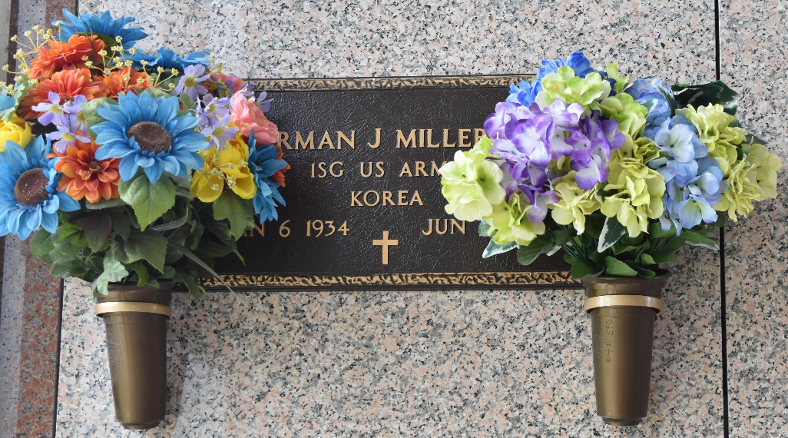

Herman J. Miller, Jr. passed away on Monday, June 4, 2018 at the age of 84. He was a native of Galveston, TX and a resident of LaPlace, LA.
Herman proudly served his country in the U. S. Army and retired after 34 years of service. During the Korean War he was a paratrooper and tank commander and later became a Battalion Fire Support Sergeant in the Battalion Washington Artillery.
He volunteered for the LaPlace Fire Dept, worked for National Airlines and Pan Am at Moisant Airport, was a recruiter for the Military and was a road deputy and resource officer in the schools for St. John Sheriff's Office.
Beloved husband of 64 years to Mary Velma Deville Miller. Loving father of Cornel Miller (Stephanie), Desiree Aguilar (Roy), Darren Miller, Nicole Millet (Burton) and the late Chilane Miller. Grandfather of Eric Simmons, Roy Aguilar Jr., Gabrielle Aguilar, Norman Anthony Jr., Ryan Miller, Jarret O'Pry, Chad Miller, Kesslie Gonzales, Hayley Miller, Alaina Tate, Ethan illet, Shawn Millet and the late Joshua Simmons and Katherine Arthur. Also survived by 35 great grandchildren and his dear friend, Patrick Wellmeyer.
He was preceded in death by his parents, Herman J. Miller, Sr. and Juanita Vasquez Miller and siblings, Patricia Torrez and Robert J. Miller.
Relatives and friends are invited to attend the Funeral Mass at St. Joan of Arc Catholic Church, 529 W. 5th St., LaPlace on Monday, June 11, 2018 at 12:00 p.m. Visitation will begin in church at 10:00 a.m. Interment in St. John Memorial Gardens Cemetery. Arrangements by Millet-Guidry Funeral Home. To view or sign the online guest book, please visit www.milletguidry.com.
The New Orleans Advocate, Louisiana
Jun. 7 to Jun. 11, 2018

